Index

1. Lyn: 2019: Python for JS Developers
2. Lyn: 2019: Python Quick Start
3. Lyn: 2019: Learning Python
4. Lyn: Python for Students
5. Lyn: 2017 Python Essential Training
6. Lyn: 2020 Python Object-Oriented Programming
7. Lyn: 2019 Python Essential Libraries
8. Lyn: 2019 Learning the Python 3 Standard Library
9. Lyn: 2019 Python Standard Library Essential Training
10. 8

**Lyn: Python for JS Developers**

**// 002 What you should know**

🡪JS oops

🡪Lyn: Learning Python

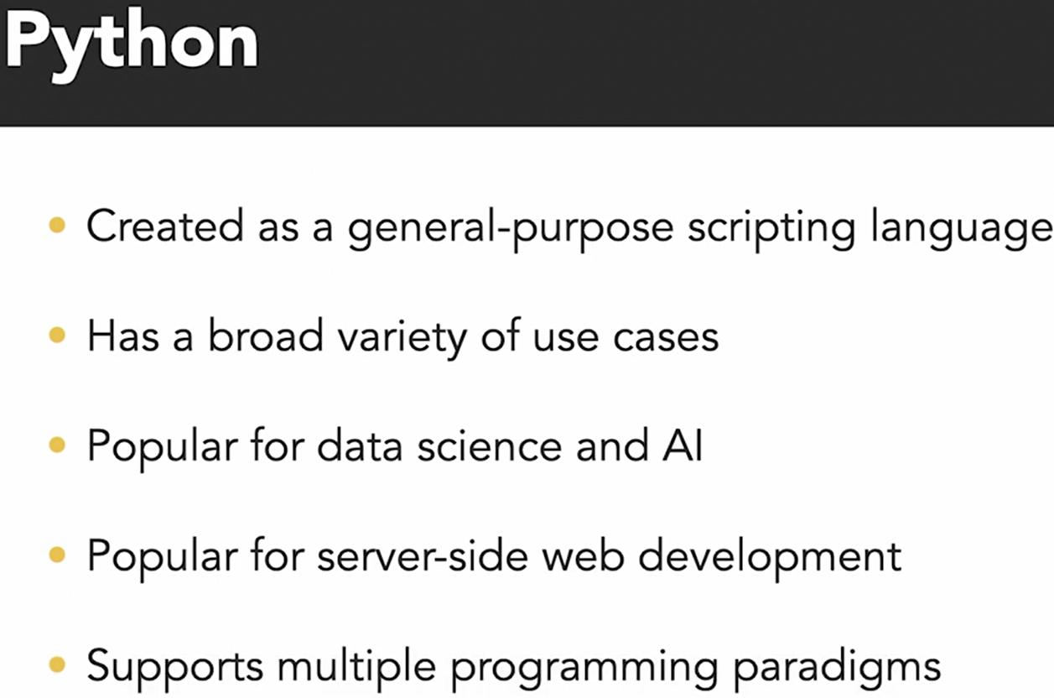**// 101 Compare Python to JS universe**

Python, refer to CPython interpreter mostly by people

There are other interpreter / implementations of Python also.

**// 102 Setting up env Python pip, pipenv**

**venv** : it is a tools comes with python for creating virtual environment. In python, it is considered best practice to manage dependencies during project development.

<https://docs.python.org/3/library/venv.html>

<https://docs.python.org/3/tutorial/venv.html>

There are other dependencies manage tools available also for python. **pipenv** is a Python virtualenv management tool that supports a multitude of systems and nicely bridges the gaps between pip, python (using system python, pyenv or asdf) and virtualenv. Linux, macOS, and Windows are all first-class citizens in pipenv.

<https://pypi.org/project/pipenv/>

🡪To create virtual env on project level using venv

python -m venv <name-of-env>

For our example, we used

python -m venv venv

// the name of vitual environment could be any

🡪To activate created environment

Linux/Mac: source venv/bin/activate

Windows: ./<name-of-env>/Scripts/activate

Command line will change to

(<name-of-env>) …. $

🡪To deactivate when it is running, run

deactivate

🡪Install dependencies at project root folder  
Keep all in <any-name>.txt

For example:

pytz==2020.4

sqlparse==0.4.1

And run from cmd when virtual env is activated:

* pip install -r <name-of-dependencies-list-file>.txt

Once completed install, final message will be:

* Successfully installed

**// 103 Common ways of running python program**

🡪From cmd

🡪As a web server

🡪Using Jypyter Notebook

To run a simple python script

* python index-script.py

**// 104 Debug python with ipdb**

**pdb** — The Python Inbuild Debugger, is a part of Python's standard library.

<https://docs.python.org/3/library/pdb.html>

Other most used external package for debug:

**ipdb** exports functions to access the IPython debugger, which features tab completion, syntax highlighting, better tracebacks, better introspection with the same interface as the pdb module.

<https://www.geeksforgeeks.org/using-ipdb-to-debug-python-code/>

[https://pypi.org/project/ipdb/](https://pypi.org/project/ipdb/0.7/)

While code stops at breakpoint, we can type variable name for which we need see value for. Also we can use tab to auto-fill variable name.

import ipdb; ipdb.set_trace()

Shortcuts while in debug mode with ipdb

ll // (double small L) to show more code on breakpoint

next n // Execute the current line and move to the next one

step s // Step into the function call on the current line

continue c

// Continue execution until the next breakpoint or the end of the program

print p // Print the value of a variable

quit q // Quit the debugger

ipdb features

* Fully compatible with PDB
* Additional features such as post-mortem debugging and the ability to set breakpoints at specific columns.
* Syntax highlighting
* Tab-completion.
* Allows you to customize the way that your debugger display looks

**//Extras**

**🡪String template**

return f"Hi {name}!" *// filling name in string*

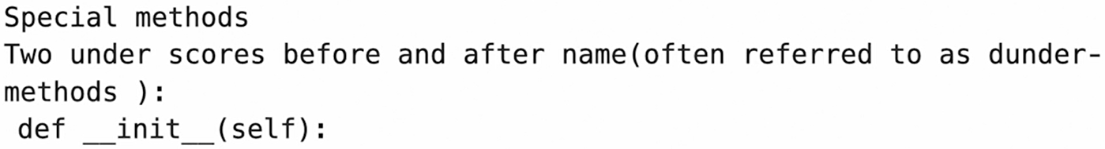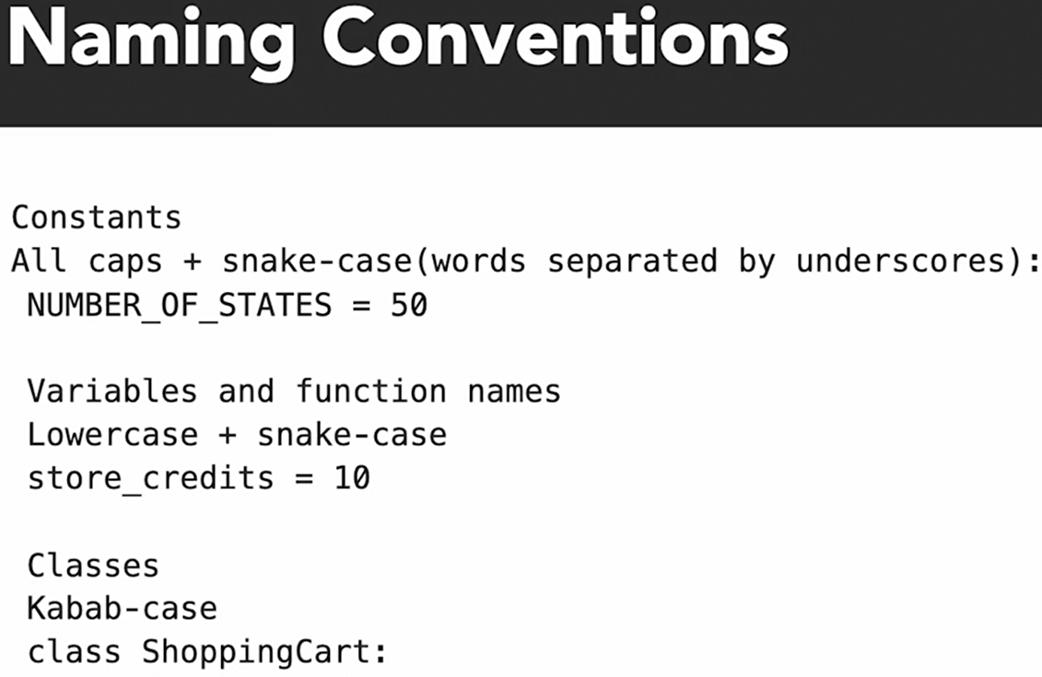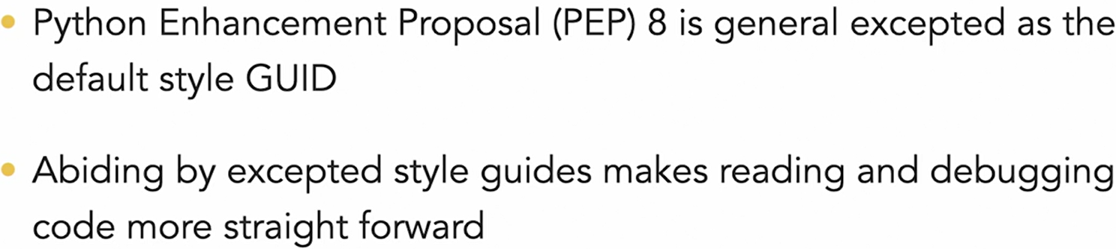**// 201 Why style is crucial**

**// 202 Numbers and Decimal types**

from decimal import Decimal

unexpected = 0.2 + 0.1

expected = Decimal("0.2") + Decimal("0.1")

**print(f"float 0.2 + 0.1 = {unexpected}")**

print(f"decimal Decimal('0.2') + Decimal('0.1') = {expected}")

*>output*

**float 0.2 + 0.1 = 0.30000000000000004**

decimal Decimal('0.2') + Decimal('0.1') = 0.3

**This is same behaviour is similar to javascript output.**

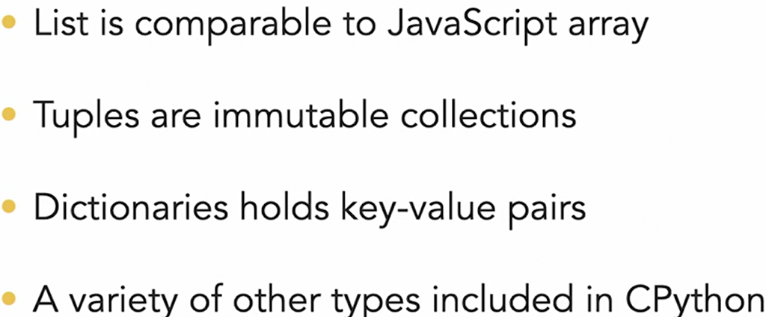**// 203 Migrating from array to python tuples, dict and list**

**\* lists may be modified**

**\* tuples are leaner and immutable**

List Example:

names = ["Ronnie", "Mona", "Jack"]

names[2] = "Fred"

print(names)

result = 1 in [1, 2, 3, 4, 5] # True

print(result)

Tuple Example:

names_tuple = (

"Ronnie",

"Mona",

"Jack",

)

# Tuple cannot be changed once defined, does not support item assignment

# Below line will result in an error, because not changeable

names_tuple[2] = "Fred"

Dictionary Example:

names_age_dictionary = {"Jack": 20, "Jill": 21, "Hill": 1000}

print(names_age_dictionary["Jill"])

print(names_age_dictionary["Hill"])

**// 204 Working with strings**

NAME = "Ronnie"

greet = f"Hi {NAME}!"

formal_greet = greet.replace("Hi", "Greetings")

string_contains_name = NAME in greet # True

string_starts_with_hi = greet.startswith("Hi") # True

string_ends_with_hi = greet.endswith("Hi") # False

print("greet :", greet)

print("formal_greet :", formal_greet)

print("string_contains_name :", string_contains_name)

print("string_starts_with_hi :", string_starts_with_hi)

print("string_ends_with_hi :", string_ends_with_hi)

*// output*

greet : Hi Ronnie!

formal_greet : Greetings Ronnie!

string_contains_name : True

string_starts_with_hi : True

string_ends_with_hi : False

**// 205 Python Slices like js array slice**

AGES = [22, 82, 45, 100]

first_item = AGES[0] # 22

last_item = AGES**[-1**] # 100

first_two_items = AGES**[:2**] # [22, 82]

last_two_items = AGES**[2:]** # [45, 100]

middle_items = AGES[**1:3**] # [82, 45]

total = sum(AGES) # 249

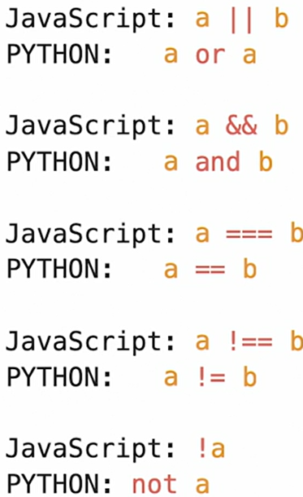

**// 301 Using colon instead of braces for func**

**// 302 Control Flow**

**// 303 How loop differ Python vs JS**

my_list = [1, 2, 3]; i = 0

while i < len(my_list): print(my_list[i]); i += 1

print("\nfor loop")

for i in my_list: print(i)

**// 304 Try except in Python vs Try Catch in JS**

# geeksforgeeks.org/try-except-else-and-finally-in-python

try: print(F”error in variable {corrupt_var_name} “)

except KeyError: print(“error”)

except Exception as e: print(“global exception handler”)

else: # execute if no exception

finally: # always execute at last

**// 305 Loop on Dict**

FRIENDS = [

{"name": "Graham"},

{"name": "John"},

{"name": "Michael"}

] # Members of Monty Python comedy troupe!

for friend in FRIENDS:

if "a" in friend["name"]: print(f"Hey {friend['name']}!")

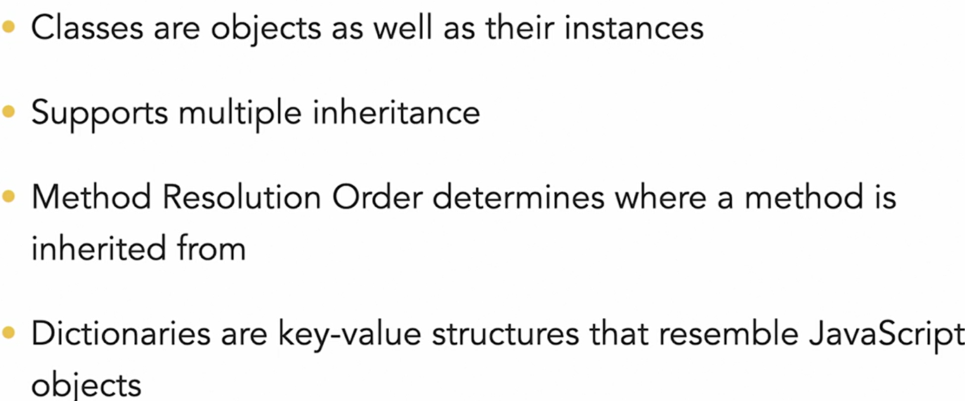**// 401 Classes, Objects, Inheritance in Python**

**// 402 Class definition in Python**

class Soup: #Kabab Casing

def __init__(self, **name="Optional-with-default-value"):**

self.name = name

self.veggies = ["tomatoes", "onions"]

def print_veggies(self):

print(f"{self.name} soup with: ")

for veggie in self.veggies:

print(f"* {veggie}")

soup_instance = Soup("ExSoup") ***# Creating Obj***

soup_instance.print_veggies()

Soup().print_veggies() **# Call without instance**

# Output after run as:

ExSoup soup with:

* tomatoes

* onions

Optional-with-default-value soup with:

* tomatoes

* onions

**// 403 Super powers with Data Model**

Methods name begins and ends with two under-scores

Example: __init__

These are special methods or dunder methods. Are powerful API that lets us interact with Python interpreter

**# Dunder is short-form for double under scores**

class Toppings:

def __init__(self):

self.items = ["tomato sauce", "peppers", "olives"]

def __len__(self):

*# Extended global python interpreter func behaviour for this class instance*

return len(self.items)

class Dough:

def __add__(self, other):

if type(other) == Toppings:

print("Did someone say pizza 🍕🍕🍕")

dough = Dough()

toppings = Toppings()

print(f"There are {len(toppings)} toppings.")

dough + toppings

# Output after run as:

There are 3 toppings:

Did someone say pizza 🍕🍕🍕

**// 404 Inheritance and Mixins**

**Mixin Pattern:**

1. **Straightforward way to compose classes**
2. **Adheres to DRY (don’t repeat yourself)**

# passing context to class

OR

# making an extended class

class VeggieSoup(VeggieMixin, SoupMixin, FoodMixin):

pass

# Here pass context to FoodMixin with context from

# VeggieMixin and SourMixin

# Created new class **VeggieSoup** with final mixing of all three

import time

class VeggieMixin:

veggies = ["tomatoes", "onions", "carrots", "brocholi"]

class SoupMixin:

temprature = "199.4°F"

water_percentage = 50

cooking_time = 1

class SaladMixin:

temprature = "41.0°F"

water_percentage = 0

cooking_time = 0

class FoodMixin:

def make_food(self):

print(f"Making wait {self.cooking_time} seconds")

time.sleep(self.cooking_time) # time sleep

print(self.water_percentage, " percent water")

print(self.temprature)

class VeggieSoup(VeggieMixin, SoupMixin, FoodMixin):

pass # means no further code for this definition

class VeggieSalad(VeggieMixin, SaladMixin, FoodMixin):

pass # good in case when making wrapper class

VeggieSoup().make_food()

VeggieSalad().make_food()

**// 405 Challenge**

# Using mixin to achieve code reusability

# Using decorator: @property

class UserMixin:

**@property**

def data(self):

return [

{"id": 1, "name": "Bill", "store_credits": Decimal("10")}, …, ]

class ListMixin():

def get(self, request, format=None):

return Response(**self.data**, status=status.HTTP_200_OK)

class ItemListView(APIView, ItemsMixin, ListMixin):

pass

# after it we can use self.data to refer to array returned

**// 501 range, zip, getsizeof**

zero_to_nine = [0, 1, 2, 3, 4, 5, 6, 7, 8, 9]

for num in zero_to_nine: print(num) # print 0 to 9

**from sys import getsizeof**

a_range = **range**(9) # range takes less space in memory

print("a_range size => ", getsizeof(a_range)) # 48

for num in a_range: print(num) # print 0 to 8

a_list = list(a_range)

print("a_list size => ", **getsizeof**(a_list)) # 136

**// 502 Build-in method Python**

NAMES = ["Jake", "Jay", "Jim", "Jill"]

AGES = [34, 25, 55, 42]

for name, age in **zip**(NAMES, AGES):

print(f"{name} => {age}") # Jake => 34

for num in **reversed**(AGES): print(num)

for num in **sorted**(AGES): print(num)

print("=====iterating index, name with enumerate=====")

for i, name in **enumerate**(NAMES):

print(i, name) # 0 Jake

**// 503 Build-in Comprehensions Python**

**import ipdb**

ZERO_TO_FOUR = [0, 1, 2, 3, 4]

NEW_LIST = [number + 1 for number in ZERO_TO_FOUR]

FILTER_NEW_LIST = [

number for number in NEW_LIST if number > 2 ]

**ipdb.set_trace()** # setting breakpoint for debugger

FRIENDS = [ {"name": "Graham"}, {"name": "Eric"},

{"name": "Michael"} ]

NAME_STR = [ friend["name"] for friend in FRIENDS ]

NAMES_WITH_H = [str for str in NAME_STR if "h" in string]

**ipdb.set_trace()** # setting breakpoint for debugger

**// 504 Decorators Python**

// Flask python web framework use decorators highly

// Most basic decorator as below:

def add_greet(func):

name = func()

print(f"hey {name}!") # hey Terry!

**@add_greet**

def get_name(): return "Terry"

**// 505 Challenge Map to comprehension**

name = “Panku Patri”

name_lower = name.lower() # panku patri

**// 601 Other Python Study resources**

Lyn: Building a personal portfolio with Django

Lyn: Data Science Foundation Python Scientific Stack

Lyn: Secure Coding in Python

**Lyn: 2019: Python Quick Start [ Lavanya Vijayan ]**

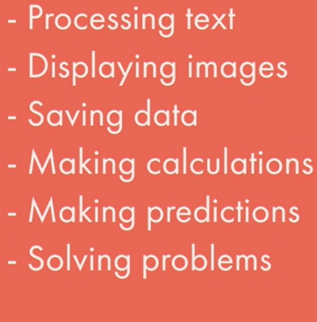**// 101 Python ?**

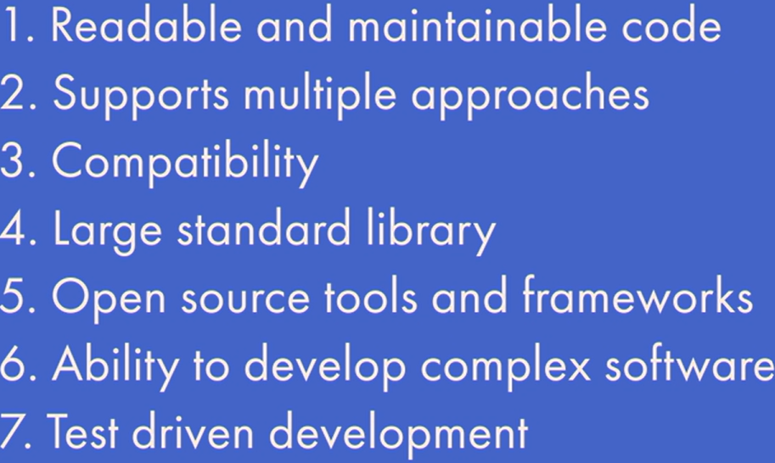**// 102 Why Python**

**// 201 Setup Python Env**

Jupyter Notebook

Anaconda is a distribution of the Python and R programming languages for scientific computing, that aims to simplify package management and deployment. The distribution includes data-science packages suitable for Windows, Linux, and macOS.

**// 202 Types in Python**

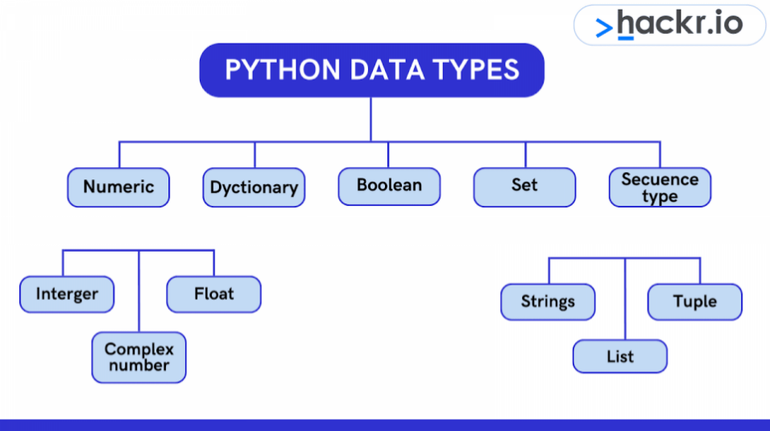

5e10 = 10 * 10 * 10 * 10 * 10

5e-10 = -10 * -10 * -10 * -10 * -10

**// 203 Data variables // 301 Functions**

**// 302 Built-in functions // 303 Define func**

**// 304 Types of Functions**

**// 305 Python Modules**

**calendar is a module in python**, which has many useful methods related to calendar

import calendar

cal = calendar.**month**(2019,7)

print(cal)

<https://docs.python.org/3/library/calendar.html>

Some other build-in modules:

<https://docs.python.org/3/library/datatypes.html>

<https://docs.python.org/3/library/index.html>

import math

res = math.**sqrt**(49) # 7

**Choosing random item from given sequence**

import random

watch = random.**choice**(moviesList)

random.**shuffle**(moviesList) *# shuffle items in sequence*

**// 401 Sequence Type?**

Sequence: Strings, List, Tuple

**// 402 Lists // 403 Tuples** cannot be modified once defined

**// 501 Conditional Statement**

ka = “3”; print(type(ka)); na = int(ka); print(type(na));

**// 502 If Statement // 503 If-else statement**

**// 504 if elif if elif else**

if x < y: return “x is smaller”

elif x > y: return “y is smaller”

else: return “x and y are equal”

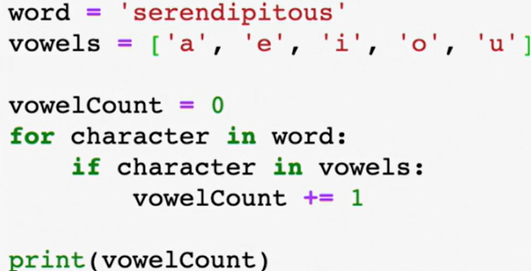**// 601 Iteration**

**// 602 For loop**

* 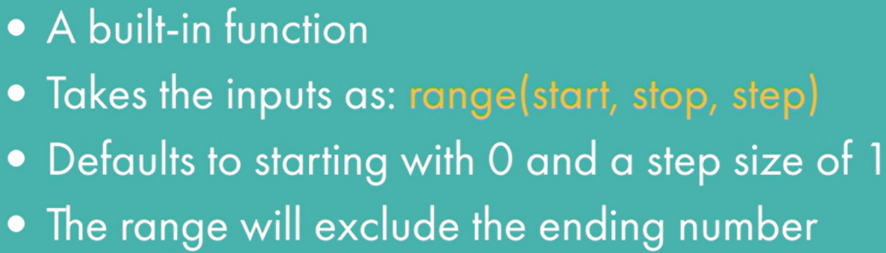range

for i in range(1, 8, 2): print(i) # 1 3 5 7

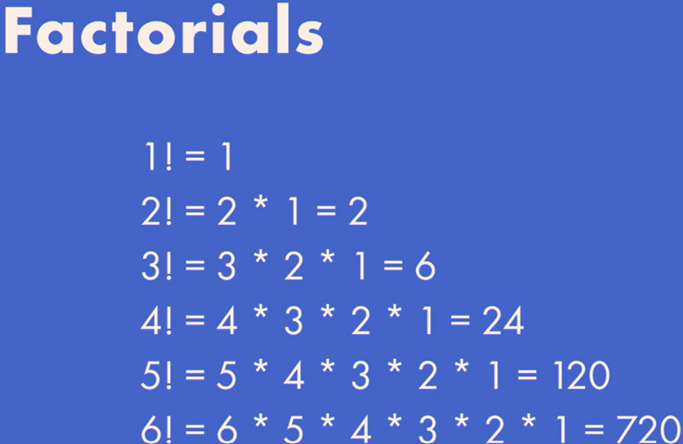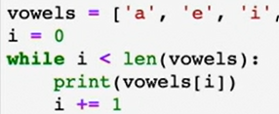**// 603 While**

**// 701 Recursive Function**

def fac(n):

if n == 1: return 1

else: return n* fac( n – 1 )

**# factorial math formula n! = n(n-1)(n-2)…. OR n != n (n-1)!**

**// 702 Define recursive func**

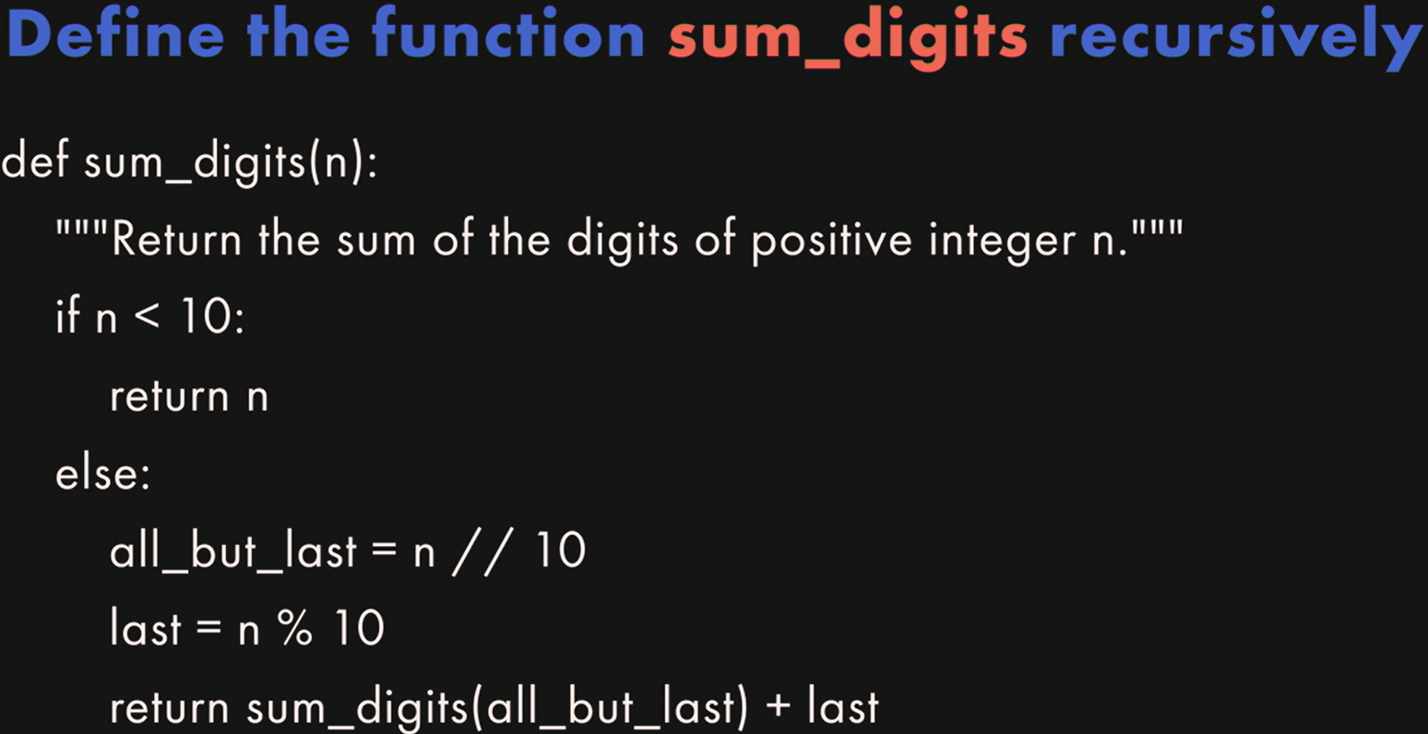Sum of the digits = sum of all digits before last digit + last digit

**Using triple single/double quotes for multi-line string value**

**my_str = """I \**

**am \**

**Geek !"""**

* Palindrome or not ?

Words like: mom, k, 5, 121, 1221, etc.

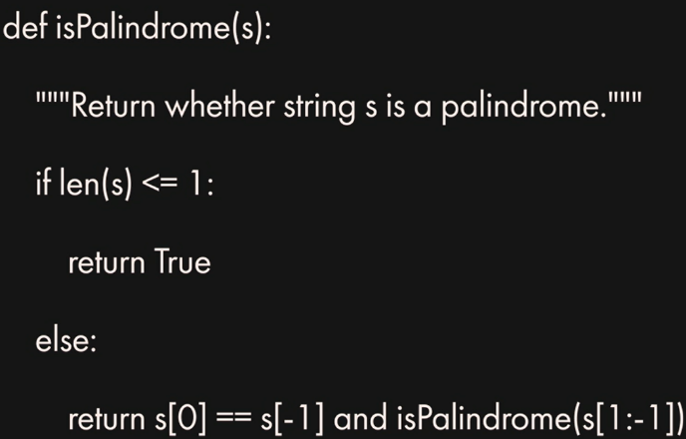

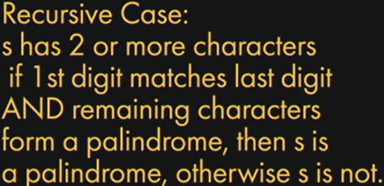

**// 801 OOPS**

**// 901 Next**

*Lavanya Vijayan – Python & Data Science Instructor*

**Lyn: 2019: Learning Python**

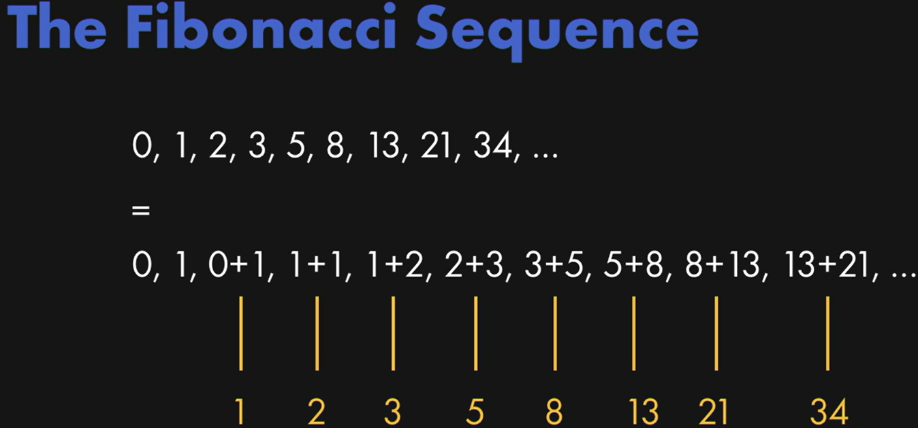**// 103 VSCode dev settings**

1. Ctrl + , for opening settings for VSCode
2. Search executeinfiledir 🡪Check it  
   When executing a file in the terminal, whether to use execute in the file’s directory, instead of the current open folder
3. 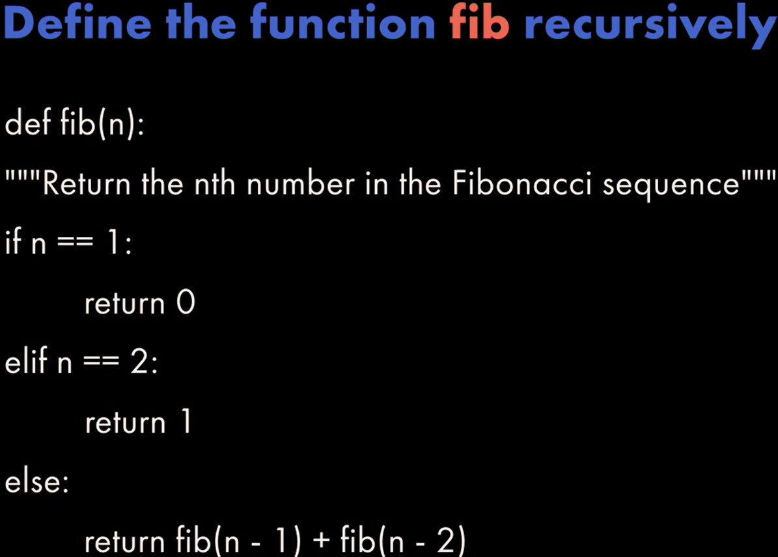Few other helpful VSCode extension:
   1. Python, Pylance
   2. Python Debugger
4. Use latest VSCode
5. From Left side bar 🡪Run and Debug  
   🡪Create a launch.json  
   🡪Python File: Debug the currently active Python file

Add extra lines to configurations launch.json

“cwd”: “${fileDirname}”,

“stopOnEntry”: true,

“console”: “internalConsole”

// in case you want to use debugConsole comes with VSCode

code.visualstudio.com/docs/python/debugging

**// 201 Py program from terminal**

Python is interpreted language as Javascript, so each line it interpreted and execute when get hit.

**To find whether we are running our code on main module or not, we can use**

def main(): print("hello world!")

**if __name__ == "__main__": main()**

**# Here we are looking special global variable from py __name__ which reflects module name**

**and checking whether we running it directly or not**

**# If the file with this code is imported by other module, then if statement will fail, as it won’t be the __main__ module for that program. So our main() func won’t get execute automatically until explicitly triggered.**

**// 202 Run py in VSCODE // 203 Variables**

f = “abc”; print(f)

print(“str “ + str(123)) *# type-cast number to string*

def someFunction():

**global f** # re-use var f from outer scope

# else it will create new local var f

f = "def"; print (f)

**del f**  # delete definition of variable previously declared

print(f) # NameError: name 'f' is not defined

**// 204 Functions**

# function with default value for an argument

def power(num, x=1):

result = 1

for i in range(x): result = result * num

return result

# function with variable number of arguments

def multi_add(*args):

result = 0

for x in args: result = result + x

return result

print(power(2)) # 2

print(power(2, 3)) # 8

print(power(x=3, num=2)) # 8

print(multi_add(4, 5, 10, 4)) # 23

**// 205 Conditional Structure // 206 Loop**

# using the enumerate() function to get index

days = ["Mon","Tue","Wed","Thu","Fri","Sat","Sun"]

for index, day in enumerate(days): print (index, day)

**// 207 Class**

class MyClass():

def method1(self): print("MyClass method1")

def method2(self, someString):

print("MyClass method2: " + someString)

class AnotherClass(MyClass): **# inherit MyClass**

def method1(self):

MyClass.method1(self)

print("AnotherClass method1")

def main():

c = MyClass(); c.method1(); c.method2("This is a string")

c2 = AnotherClass(); c2.method1()

**// 208 Import using modules**

import math; print(math.pi)

**// 301 date_time and datetime classes**

from datetime import date

from datetime import datetime

def main():

## DATE OBJECTS

# Get today's date from the simple today() method from the date class

today = date.today(); print ("Today's date is ", today)

# 2024-04-16

# print out the date's individual components

print ("Date Components: ", today.day, today.month, today.year) # 16 4 2024

# retrieve today's weekday (0=Monday, 6=Sunday)

print ("Today's Weekday #: ", today.weekday()) # 1

days = ["monday","tuesday", … ]

print ("Which is a " + days[today.weekday()]) # tuesday

## DATETIME OBJECTS

# Get today's date from the datetime class

today = datetime.now(); print("Current date time", today)

# 2024-04-16 08:45:14.849748

# Get the current time

t = datetime.time(datetime.now())

print ("The current time is ", t) # 08:45:14.849748

**// 302 format time output**

now = datetime.now()

print (now.strftime("%a, %d %B, %y")) # Tue, 16 April, 24

print (now.strftime("Locale date and time: %c"))

print (now.strftime("Locale date: %x"))

print (now.strftime("Locale time: %X"))

%m/%d/%y = 03/15/24

# %I/%H - 12/24 Hour, %M - minute, %S - second,

# %p - locale's AM/PM

now.strftime("Current time: %I:%M:%S %p")

# 12-Hour:Minute:Second AM/PM

now.strftime("24-hour time: %H:%M") # 24-Hour:Minute

%b-%d-%Y = Dec-27-2022

**// 303 Using timedelta objects**

from datetime import date

from datetime import datetime

from datetime import timedelta

# construct a basic timedelta and print it

print (timedelta(days=365, hours=5, minutes=1))

# print today's date

now = datetime.now(); print ("today is: " + str(now))

# print today's date one year from now

print ("one year from now it will be: " + str(now + timedelta(days=365)))

# create a timedelta that uses more than one argument

print ("in two weeks and 3 days it will be: " +

str(now + timedelta(weeks=2, days=3)))

# calculate the date 1 week ago, formatted as a string

t = datetime.now() - timedelta(weeks=1)

s = t.strftime("%A %B %d, %Y")

print (s)

### How many days until April Fools' Day?

today = date.today() # get today's date

afd = date(today.year, 4, 1) # get April Fool's for same year

# use date comparison to see if April Fool's has already gone

# if it has, use the replace() function get the date for next year

if afd < today:

print ("April Fool's day already went by %d days ago" % ((today-afd).days))

afd = afd.replace(year=today.year + 1) # if so, get the date for next year

# Now calculate the amount of time until April Fool's Day

time_to_afd = afd - today

print ("It's just", time_to_afd.days, "days until nxt April Fool")

**// 304 Working with Calendars**

import calendar

# create a plain text calendar

c = calendar.TextCalendar(calendar.SUNDAY)

str = c.formatmonth(2017, 1, 0, 0); print (str)

# create an HTML formatted calendar

hc = calendar.HTMLCalendar(calendar.SUNDAY)

str = hc.formatmonth(2017, 1); print (str)

# loop over the days of a month

# zeroes mean that day of the week is in an overlapping mont

for i in c.itermonthdays(2017, 8): print (i)

# The Calendar module provides useful utilities for the given locale, such as the names of days and months in both full and abbreviated forms

for name in calendar.month_name: print (name)

for day in calendar.day_name: print (day)

# Calculate days based on a rule: For example, consider

# a team meeting on the first Friday of every month.

# To figure out what days that would be for each month,

# we can use this script:

print ("Team meetings will be on:")

for m in range(1,13):

# returns an array of weeks that represent the month

cal = calendar.monthcalendar(2017, m)

# The first Friday has to be within the first two weeks

weekone = cal[0]; weektwo = cal[1]

if weekone[calendar.FRIDAY] != 0: meetday = weekone[calendar.FRIDAY]

else: meetday = weektwo[calendar.FRIDAY]

# if the first friday isn't in the first week, it must be in the second

print ("%10s %2d" % (calendar.month_name[m], meetday))

**// 401 Reading writing to files**

# Open a file for writing and create it if it doesn't exist

f = open("textfile.txt","w+")

# Open the file for appending text to the end

# f = open("textfile.txt","a+")

# write some lines of data to the file

for i in range(10): f.write("This is line %d\r\n" % (i+1))

f.close() # close the file when done

# Open the file back up and read the contents

f = open("textfile.txt","r")

if f.mode == 'r':

# check to make sure that the file was opened

# use the read() function to read the entire file

# contents = f.read()

# print (contents)

fl = f.readlines() # readlines reads individual lines into a list

for x in fl: print (x)

**// 402 OS path utilities**

import os

from os import path

import datetime

from datetime import date, time, timedelta

import time

print (os.name) # Print the name of the OS

# Check for item existence and type

print ("Item exists: " + str(path.exists("textfile.txt")))

print ("Item is a file: " + str(path.isfile("textfile.txt")))

print ("Item is a directory: " + str(path.isdir("textfile.txt")))

# Work with file paths

print ("Item's path: " + str(path.realpath("textfile.txt")))

print ("Item's path and name: " + str(path.split(path.realpath("textfile.txt"))))

# Get the modification time

t = time.ctime(path.getmtime("textfile.txt")); print (t)

print (datetime.datetime.fromtimestamp(path.getmtime("textfile.txt")))

# Calculate how long ago the item was modified

td= datetime.datetime.now() - datetime.datetime.fromtimestamp(path.getmtime("textfile.txt"))

print ("It has been " + str(td) + " since the file was modified")

print ("Or, " + str(td.total_seconds()) + " seconds")

**// 403 file system shell methods**

import os

from os import path

import shutil

from shutil import make_archive

from zipfile import ZipFile

# make a duplicate of an existing file

if path.exists("textfile.txt"):

# get the path to the file in the current directory

src = path.realpath("textfile.txt");

# let's make a backup copy by appending "bak" to the name

dst = src + ".bak"

# now use the shell to make a copy of the file

shutil.copy(src,dst)

# copy over the permissions, modification time, other info

shutil.copystat(src, dst)

# # rename the original file

os.rename("textfile.txt", "newfile.txt")

# now put things into a ZIP archive

root_dir,tail = path.split(src)

shutil.make_archive("archive", "zip", root_dir)

# more fine-grained control over ZIP files

with ZipFile("testzip.zip","w") as newzip:

newzip.write("newfile.txt")

newzip.write("textfile.txt.bak")

**// 501 fetch internet data**

import urllib.request # instead of urllib2 like in Python 2.7

# open a connection to a URL using urllib2

webUrl = urllib.request.urlopen("http://www.google.com")

# get the result code and print it

print ("result code: " + str(webUrl.getcode()))

# read the data from the URL and print it

dataStr = webUrl.read(); print (dataStr)

**// 502 json**

import urllib.request # instead of urllib2 like in Python 2.7

import json

urlData = <https://earthquake.usgs.gov/earthquakes/feed/v1.0/summary/2.5_day.geojson> # Open the URL and read the data

webUrl = urllib.request.urlopen(urlData)

if (webUrl.getcode() == 200):

data = webUrl.read().decode("utf-8")

printResults(data)

def printResults(data):

# Use the json module to load the string data into dict

theJSON = json.loads(data)

# access the contents of the JSON like any other object

if "title" in theJSON["metadata"]:

print(theJSON["metadata"]["title"])

# number of events plus the magnitude and event name

count = theJSON["metadata"]["count"]

print(str(count) + " events recorded")

# for each event, print the place where it occurred

for i in theJSON["features"]:

if 'U.S.' in i["properties"]["place"]:

print(i["properties"]["place"] )

print("--------------\n")

# print events that only have a magnitude greater than 4

# print decimal upto 1 position only ex 4.18 to 4.1

for i in theJSON["features"]:

if i["properties"]["mag"] >= 4.0:

print**("%2.1f"** **% i["properties"]["mag"],** i["properties"]["place"])

# events where at least 1 person reported something

**# null value converts to None by json.loads**

print("\n\nEvents that were felt:")

for i in theJSON["features"]:

feltReports = i["properties"]["felt"]

if (feltReports != None and feltReports > 0):

print("%2.1f" % i["properties"]["mag"], i["properties"]

["place"], " reported " + str(feltReports) + " times")

**Extras: json.dumps()**

https://www.geeksforgeeks.org/json-dumps-in-python/

json.dumps() function will convert a subset of Python objects into a json string. Not all objects are convertible and you may need to create a dictionary of data you wish to expose before serializing to JSON.

**Syntax:**

**json.dumps(obj, *, skipkeys=False, ensure_ascii=True, check_circular=True, allow_nan=True, cls=None, indent=None, separators=None, default=None, sort_keys=False, **kw)**

**Parameters: obj:** Serialize obj as a JSON formatted stream

skipkeys: If skipkeys is True (default: False), then dict keys that are not of a basic type (str, int, float, bool, None) will be skipped instead of raising a TypeError.

ensure_ascii: If ensure_ascii is True (the default), the output is guaranteed to have all incoming non-ASCII characters escaped. If ensure_ascii is False, these characters will be output as-is.

check_circular: If check_circular is False (default: True), then the circular reference check for container types will be skipped and a circular reference will result in an OverflowError (or worse).

allow_nan: If allow_nan is False (default: True), then it will be a ValueError to serialize out of range float values (nan, inf, -inf) in strict compliance of the JSON specification. If allow_nan is True, their JavaScript equivalents (NaN, Infinity, -Infinity) will be used.

indent: If indent is a non-negative integer or string, then JSON array elements and object members will be pretty-printed with that indent level. An indent level of 0, negative, or “” will only insert newlines. None (the default) selects the most compact representation. Using a positive integer indent indents that many spaces per level. If indent is a string (such as “\t”), that string is used to indent each level.

separators: If specified, separators should be an (item_separator, key_separator) tuple. The default is (‘, ‘, ‘: ‘) if indent is None and (‘, ‘, ‘: ‘) otherwise. To get the most compact JSON representation, you should specify (‘, ‘, ‘:’) to eliminate whitespace.

default: If specified, default should be a function that gets called for objects that can’t otherwise be serialized. It should return a JSON encodable version of the object or raise a TypeError. If not specified, TypeError is raised.

**sort_keys**: If sort_keys is True (default: False), then the output of dictionaries will be sorted by key.

**// 503 parsing processing HTML** *--- skipped very complex*

**// 504 XML manipulation**

# Operate on xml data while it is sitting in memory

Example XML Used samplexml.xml:

<?xml version="1.0" encoding="UTF-8" ?>

<person>

<firstname>Joe</firstname>

<lastname>Marini</lastname>

<home>Seattle</home>

<skill name="JavaScript"/>

<skill name="Python"/>

<skill name="C#"/>

<skill name="HTML"/>

</person>

import xml.dom.minidom

# use the parse() function to load and parse an XML file

doc = xml.dom.minidom.parse("samplexml.xml")

# print the document node and the name of the first child tag

print (doc.nodeName) # #document

print (doc.firstChild.tagName) # person

# get a list of XML tags from the document and print each one

skills = doc.getElementsByTagName("skill")

print ("%d skills:" % skills.length) # 4 skills:

for skill in skills: print (skill.getAttribute("name"))

# create a new XML tag and add it into the document

newSkill = doc.createElement("skill")

newSkill.setAttribute("name", "jQuery")

doc.firstChild.appendChild(newSkill)

skills = doc.getElementsByTagName("skill")

print ("%d skills:" % skills.length) # 5 skills:

**Lyn: Python for Students**

**// 101 What is Python**

High level general purpose language

**// 102 Why python // 103 Python Power**

Web apps: Flask, Django

Scientific computing: math, stats, scientist - Numpy, Pandas

Automation

**// 203 Python 2 vs Python 3**

Py3: 2008 not compatible with py 2

Py2 stops jan 2020 support, mac may be using py2 some place

**// 204 Py shell // 205 Python files**

**// 301 Numbers basic calculation**

🡪Division in py always output float number

print(4/2) # 2.0 # see it results float number always

🡪Adding or subtract anything on float will result in float o/p

**// 302 Strings**

print(‘’’Dear

John, this is multi-line string’’’)

strEx = ‘heLLo’; print(strEx**.upper()**); #HELLO

* <https://docs.python.org/2/library/string.html>

print(strEx**.title())** # Hello

**f strings ? example**:name: “pat”; print(**f”**Dog name {name}”)

**// 401 Variables // 402 Functions**

Using wrong variable name raise NameError

**// 501 List** a_list = [1, 2, 3]; a_list**.append**(4);

a_list**.insert**(1, 11); print(**len**(a_list)) # 5

print(a_list) # [ 1, 11, 2, 3, 4 ]

**del** a_list[1]; a_list**.pop**(); print(a_list) # [ 1, 2, 3 ]

list_of_lists = [ [1,2], [3,4] ]

print(list_of_lists**[-1])** # [3,4] last item in list by using -1

Note: **IndexError** on calling list_of_lists[2]

a_list**.remove(2) # remove first instance of value 2 in a_list**

**// 701 Mini drawing program using turtle library**

**// 702 Draw line // 703 Circle // 704 Pizza // skip**

<https://docs.python.org/3/library/turtle.html>

**// 801 Editor**

PyCharm, Sublime, Jupyter Notebook with Anaconda

**// 802 Python resources // 803 Stackoverflow**

**// 804 Reddit // 805 pyslackers.com** *py slack groups*

**Lyn: 2017 Python Essential Training [ Bill Weinman ]**

**// 003 About Py**

* Developed by Guido Van Rossum, Dutch
* Wrote First interpreter December, 1989
* Name inspired from Circus
* Remains principal author
* Referred as BDFL – Benevolent Dictator For Life

Python Philosophy:

* Beautiful is better than ugly
* Explicit is better than implicit
* Simple is better than complex
* Complex is better that complicated
* Readability counts

Python 3 features vs Python 2:

* Not backward compatible
* Everything is an object
* Print is a function
* One integer type
* All text is now Unicode

**// 101 Python Komodo Editor // 201 Py Overview**

import platform

print(**platform.python_version**())

**// 202 hello // 203 Py Anatomy**

**Shebang Line** (command to find python interpretor)

**#!** /usr/bin/env python3

# this line is functional for mac, bst-unix and linux system only

print(‘py ver **{}’.format**(platform.python_version() ) )

# py ver 3.12.1

**// 204 Statement and Expressions**

We can terminate statement with semi-colon ;

**// 205 Whitespace comments**

Indents works as block body of function definitions.

**True / False not true / false**

**// 206 print is more powerful vs other prog languages**

x = 4; print(‘{}’.format(x)) # 4

print(‘%d’ %x) # 4

print(f’{x}’) # 4 # usable in many cases

**// 207 Block Scope**

Only function block starts new block context in py

Other things like if, while, for do not get new block context

**// 208 Conditions // 209 Loops**

# simple fibonacci series

# the sum of two elements defines the next set

**a, b = 0, 1**

while b < 1000:

print(b, **end = ', ', flush = True**)

**a, b = b, a + b**

**# a will take b as value 1**

**# when b gets a + b, it will take prev value of a as 0**

**# run code to understand better**

*# 1, 1, 2, 3, 5, 8, 13, 21, 34, 55, 89, 144, 233, 377, 610, 987*,

**// 210 Function**

By default, if we do not explicitly return any thing

Then, function will return None as value

*docs.python.org/3/glossary.html#****term-function-annotation***

def func1(n): print(n)

x = func1(33); print(x) # None

def isprime(n):

if n <= 1: return False

for x in range(2, n):

if n % x == 0: return False

else: return True

n = 5

if isprime(n): print(f'{n} is prime') # 5 is prime

else: print(f'{n} not prime') # 6 is prime

def list_primes():

for n in range(100):

if(isprime(n)): print(n, end = ‘ ‘, flush=True)

print() # this will print empty line

# 2 3 5 7 11 13 17 19 …

**// 211 Class Objects**

**// 301 Types Values**

**// 302 String Type**

‘kumar ban’**.capitalize**() # Kumar **b**an

‘kumar ban’**.title**() # Kumar **B**an

‘a {} {}’.format(9, 8) # a 9 8

‘a {1} {0}’.format(9, 8) # a 8 9

‘ ”{1:<9}” “{0:>9}” ’.**format**(3, 5)

*# nine space add after element at position 1*

*# nine space add before element at position 0*

#a “5 “ “ 3”

‘ ”{1:<08}” “{0:>08}” ’.**format**(333, 5)

*# fill 8 zeros for empty after for element at position 1*

*# fill 8 zeros for empty before at position 0*

#a “50000000“ “00000333”

# here total output length is 8 and filled 7 zero for 5

# and filled 5 zeros to 333 to complete length of 8 characters

**// 303 Numeric Types**

print(7 // 3) # 2

print( 7 / 3 ) # 2.3333333335

print(7/3) # 1 # remainder

**Don’t use float for calculating money, instead use Decimal**

**// 304 Bool Type**

x = None; print(type(x)) # <class ‘NoneType’>

------ ------- ------ -------

0 == False # True

**// 305 Sequence Type – List, Tuple, Dictionaries**

If we try to re assign any index of Tuple

**TypeError: ‘tuple’ object does not support item assignment**

r = range(3, 5) # 3, 4

**r[1]=4 #TypeError: ‘range’ object does not support item as**

da = { ‘a’: 1, ‘b’:3 }

da[‘c’]=5

for k, v in da.items():

print(f’{k} {v}’, end = ‘, ‘) # a 1, b 3, c 5,

**// 306 Type_id**

x=1; y=1;

print(id(x)) # 140730388519352

print(id(y)) # 140730388519352

if id(x) == id(y): print(True) # True

------ ------- ------ -------

local_var = 3; local_none = None

If **‘local_var’ in locals():** print(‘Is defined’)

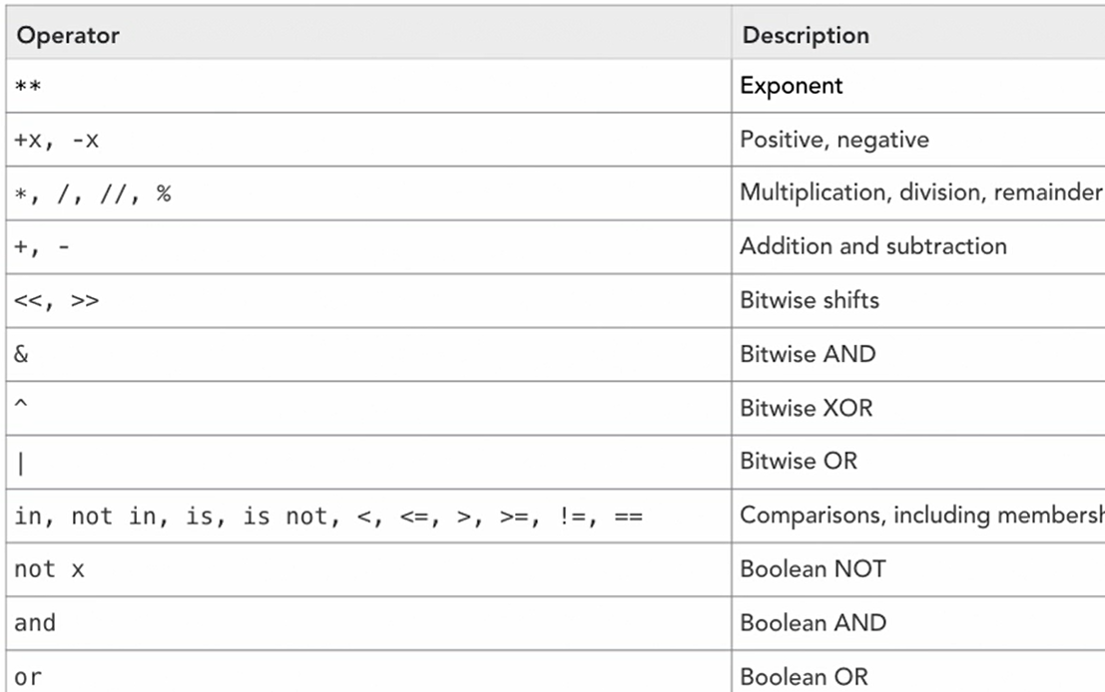If **‘local_none’ == None:** print(‘Is defined None’)

If **‘local_var’ in globals():** print(‘Is defined’)

------ ------- ------ -------

try: p; print(1);

except Exception as ex: print(2, ex)

# 2 name ‘p’ is not defined

------ ------- ------ -------

Difference b/w **is** and **==**

An **‘is’** expression evaluates to True if two variables point to the same (identical) object. compares the references

An **‘==’** expression evaluates to True if variables are equal (have the same contents).

a = [1,2]; b=[1,2]

c = list(a)

k = a

k is a # True

a is k # True

a **==**  b # True

a **is** b # False

a **is not** b # True

k[0]=4 # **reference point for a and k are same**

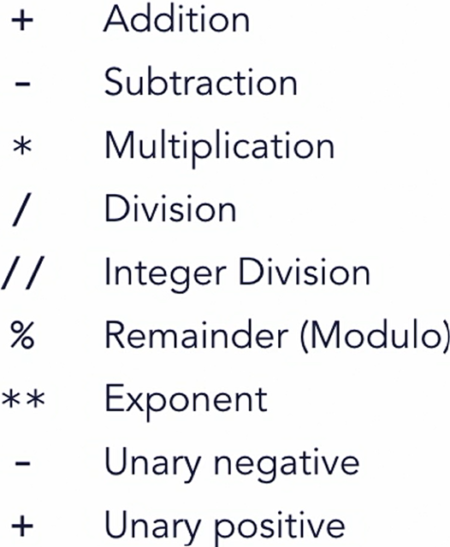print(a) # [4, 2]

print(k) # [4, 2]

**isinstance**(k, list) # True

**// 401 Conditional Syntax**

**// 402 Conditional Operators**

1 in a # True

3 **in** a # False

2 **not in** a # False

a **is** b # False

a **is not** b # True

**// 403 Conditional assignment**

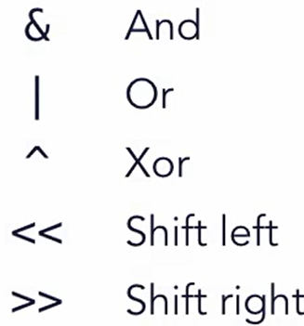# Itenary Operator or short-hand if condition

ab = True

**cb = ‘1’ if ab else 2**

*# else clause is must*

**// 501 Arithmetic Operators**

**// 502 Bitwise Operators**

& | ^ << >>

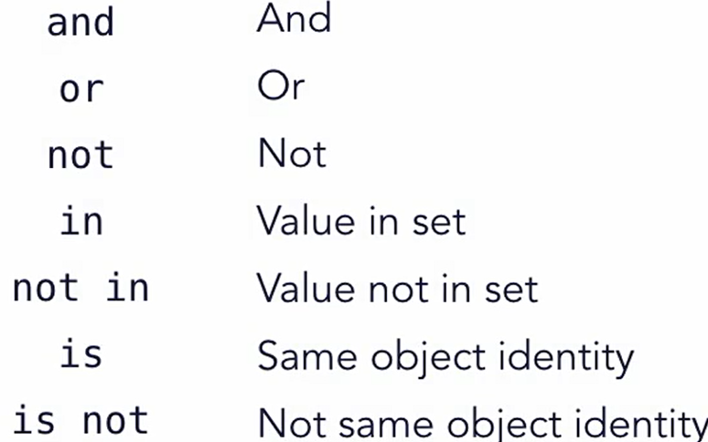**// 503 Comparison**

**// 504 Boolean Operators**

**// 505 Operator precedence**

**// 601 Loops // 602 While // 603 For loop**

**// 604 Loop controls**

continue; break; else;

------ ------- ------ -------

# else get triggered when **loop ends without break**

count = 0; p = False; max_count = 5

while p == False:

count += 1

print(‘p is not False’)

if count > max_count: break

if count == 3: **continue # will skip cycle**

**if count == 4: p = True # satisfy loop and trigger else**

**else: # using else with while loop**

print(‘count reached to 3’) **# trigger after loop ends**

**# If break terminates loop then else will not trigger**

------ ------- ------ -------

# similar behaviour of else in for loop

animals = ( 'bear', 'bunny', 'dog', 'cat', 'velociraptor' )

for pet in animals:

if pet == 'bunny': continue

# if pet == 'cat': break

print(pet)

else: print(0)

c = 0; max_c = 5

while c != 9:

c += 1

# if c == max_c: break

if c == 3: continue

print(c)

else: print(0)

**// 701 Defining a function**

**// 702 Func arguments with default value**

**call by value for int, string variables**

def main():

x = 5; print(id(x)); kitten(x); print('x', x)

def kitten(a):

print(id(a)); a = 3; print(id(a)); print('Meow.', a)

**sequence types are call by reference, such as list and dict**

**// 703 Argument Lists**

def kitten(*args):

print(type(args)) # <class ‘typle’>

print(isinstance(args, tuple)) # True

for s in args: print(s)

kitten('meow', 'grrr', 'purr', ‘he’, ‘she’) **# passing tuple**

x = ('meow', 'grrr', 'purr', ‘he’, ‘she’)

kitten(*x)

**// 704 Keyword Arguments**

def kitten**(**kwargs**):

print(type(kwargs)) # <class ‘dict’>

print(isinstance(kwargs, dict)) # True

if len(kwargs):

for k in kwargs:

print('Kitten {} says {}'.format(k, kwargs[k]))

else: print('Meow.')

def main():

kitten(Buffy = 'meow', Zilla = 'grr')

x = { Buffy = 'meow', Zilla = 'grr'}

kitten(**x)

y = dict(Buffy = 'meow', Zilla = 'grr')

kitten(**y)

**// 705 return value**

**// 706 Generator – return stream of values**

def **inclusive_range(*args): # generator**

start = 0; step = 1; stop = args[0]

i = start

**while i <= stop:**

**yield i # yield came to python later than Iterator**

**i += step**

for i in inclusive_range(5): print(i, end = ', ')

# 0, 1, 2, 3, 4, 5

**// 707 Decorator**

# General decorator pattern

def f1(f):

def f2(): print(‘before call’); f(); print(‘after call’);

return f2

------ ------- ------ -------

def f3(): print(‘f3’)

x = f1(f3); x() # plain way pattern

------ ------- ------ -------

**@f1** # decorator pattern

def f3(): print(‘f3’)

===== ===== ===== =====

import time # second example of decorator use

def elapsed_time(f):

def wrapper():

t1 = time.time(); f(); t2 = time.time()

print(f'Elapsed time: {(t2 - t1) * 1000} ms')

return wrapper

**@**elapsed_time

def big_sum():

num_list = []

for num in (range(0, 10000)): num_list.append(num)

print(f'Big sum: {sum(num_list)}')

big_sum()

**// 801 Basic data structure**

Set is ordered unique values

set_a = {1, 2, 3}

print(set_a) # { 1, 2, 3 }

set_b = { 1, 1, 2, 2, 3, 4, 3, 3, 4 } // unique value gets store only

print(set_b) # { 1, 2, 3, 4 }

**// 802 List operations**

a_list = [ ‘a’, ‘b’, ‘c’, ‘d’, ‘e’, ‘f’ ]

print(a_list[1:6:2]) # [ ‘b’, ‘d’, ‘f’ ]

append, insert, remove, pop,

del a_list[1:2] # [‘a’, ‘c’, ‘d’, ‘e’, ‘f’] // removed only ‘b’

a_list.remove(‘d’) # [‘a’, ‘c’, ‘e’, ‘f’]

**// 803 Dictionary**

a_dict = dict(a=’a1’, b=’b1’, c=’c1’)

print(a_dict[‘a’]) # a1

a_dict[‘a’] = ‘a2’

print(‘found’ if ‘b’ in a_dict else ‘nope’)

print(a_dict.get(‘b’)) # b1

**// 804 Set**

Set allow only unique value

The values in set can be sorted

def print_set(o):

print('{', end = '')

for x in o: print(x, end = '')

print('}')

a = set("We're gonna need a bigger boat.")

b = set("I'm sorry, Dave. I'm afraid I can't do that.")

print_set(a)

print_set(sorted(b))

print(**a – b**) # items which are in a but not in b

print(**a | b**) # items which are in one or both a and b

print(**a & b**) # items which are in both a and b

print(**a ^ b**) # items which are in a or b and not in both

# do not take items which are in both a and b

**// 805 List Comprehension**

seq = range(11)

seq2 = [x * 2 for x in seq]

seq3 = [ x for x in seq if x % 3 != 0]

seq4 = [(x, **x**2**) for x in seq] # square of x = x**2

# (0,0),(1,1),(2,4),(3,9),(4,16),(5,25)….

seq5 = {x for x in ‘superduper’ if x not in ‘pd’}

# u s e r # only condition passing items passed to result

**// 806 Mixed structure**

def disp(o):

**global** dlevel

dlevel += 1

if isinstance(o, list): print_list(o)

elif **isinstance**(o, range): print_list(o)

elif isinstance(o, tuple): print_tuple(o)

elif isinstance(o, set): print_set(o)

elif isinstance(o, dict): print_dict(o)

elif o is None: print('Nada', end=' ', flush=True)

else: print(repr(o), end=' ', flush=True)

dlevel -= 1

if dlevel <= 1: print() # newline after outer

def print_list(o):

print('[', end=' ')

for x in o: disp(x)

print(']', end=' ', flush=True)

def print_tuple(o):

print('(', end=' ')

for x in o: disp(x)

print(')', end=' ', flush=True)

def print_set(o):

print('{', end=' ')

for x in sorted(o): disp(x)

print('}', end=' ', flush=True)

def print_dict(o):

print('{', end=' ')

for k, v in o.items():

print(k, end=': ' )

disp(v)

print('}', end=' ', flush=True)

#global

dlevel = 0 # manage nesting level

def main():

r = range(11)

l = [ 1, 'two', 3, {'4': 'four' }, 5 ]

t = ( 'one', 'two', None, 'four', 'five' )

s = set("It's a bird! It's a plane! It's Superman!")

d = dict( one = r, two = l, three = s )

mixed = [ l, r, s, d, t ]

disp(mixed)

**// 901 Class**

**// 902 Object Instance // 903 Class methods**

class Animal:

def __init__(self, **kwargs):

self._type = kwargs['type'] if 'type' in kwargs else 'kitten'

self._name = kwargs['name'] if 'name' in kwargs else 'fluff'

self._sound = kwargs['sound'] if 'sound' in kwargs else 'ra'

def type(self, t = None):

if t: self._type = t

try: return self._type

except AttributeError: return None

def name(self, n = None):

if n: self._name = n

try: return self._name

**except AttributeError: return None**

def sound(self, s = None):

if s: self._sound = s

try: return self._sound

except AttributeError: return None

def **__str__(self**):

return f'{self.type()} "{self.name()}" says "{self.sound()}".'

class Duck(Animal): **# single inheritance**

def __init__(self, **kwargs):

self._type = 'duck'

if 'type' in kwargs: del kwargs['type']

super().__init__(**kwargs)

class Kitten(Animal):

def __init__(self, **kwargs):

self._type = 'kitten'

if 'type' in kwargs: del kwargs['type']

super().__init__(**kwargs)

def print_animal(o):

if not isinstance(o, Animal):

raise TypeError('print_animal(): requires an Animal')

print(f'{o.type()} named "{o.name()}" says "{o.sound()}"')

def main():

a0 = Kitten(name = 'fluffy', sound = 'rwar')

a1 = Duck(name = 'donald', sound = 'quack')

print_animal(a0); print_animal(a1)

print_animal(Animal(type=‘t’,name=’n’,sound=’hello’))

print(Animal()) # will pick default values

print(a1) # will use __str__ from Animal

<https://docs.python.org/3/reference/datamodel.html#special-method-names>

Note: Python do not have private variable, instead python naming convension use _var This variable should be called directly from object instance.

**// 904 Object data**

print(a0._name) # not a class level variable bind to self

**Variables at class level are shared with all objects**, means change in value of class variables can be seen in all instance objects. This is **also known as Encapsulation**. Example:

class Animal:

x = [1, 2, 4] # this is class variable and shared among all instac

def __ini__(self): …

a_anim = Animal(); b_anim = Animal()

a_anim.x[2] = 3

print(b_anim.x[2]) # 3 # all object from class share this value

**// 905 Class Inheritance**

class RevStr(str):

def __str__(self): return self[::-1] **# return str in reverse**

def main():

hello = RevStr('Hello, World.')

print(hello) # .dlroW ,olleH

**// 906 Interator Objects**

# something like generator but without using yield

class inclusive_range:

def __init__(self, *args):

numargs = len(args)

self._start = 0; self._step = 1

if numargs < 1:

raise TypeError(f'expected at least 1 argument, got {numargs}')

elif numargs == 1:

self._stop = args[0]

elif numargs == 2:

(self._start, self._stop) = args

elif numargs == 3:

(self._start, self._stop, self._step) = args

else: **raise TypeError**(f'expected at most 3 arguments, got {numargs}')

self._next = self._start

def __iter__(self): return self

def __next__(self):

if self._next > self._stop:

**raise StopIteration**

else:

_r = self._next

self._next += self._step

return _r

def main():

for n in inclusive_range(25):

print(n, end=' ')

print()

**// 1001 Handling Exceptions**

X = inet(‘asdf’) # NameError

X = int(‘asdf’) # ValueError

X = 5/0 # ZeroDivisionError

import sys

try: x = 5/0

except ValueError: print('value error')

# except ZeroDivisionError: print('zero division error')

except: # default catcher

print(f'unknown error: {**sys.exc_info**()}')

else: print('good job')

**// 1002 Reporting Error** raise TypeError(‘…’);

**// 1101 Overview String objects**

upper lower capitalize swapcase title

‘Hello’.**swapcase**() # hELLO

‘Hello {}’.format(42 * 7) # Hello 294

# strings are first-class objects in python

**// 1102 Common String methods**

.**casefold**  // more aggressive than lower, is usable for unicode

str_1 = ‘Hello’

print(id(str_1)) != print(id(str_1.lower()))

* Read docs for more such methods in python3

**// 1103 String Formatting**

print(‘ {xx} {b} {a} ‘.format(a=1,b=2,xx=3)) # 3 2 1

print(‘ {0} {2} {1} {2}‘.format(1,2,3)) # 1 3 2 3

> # right justify n number of character

< # left justify n number of character

print(‘ {0:<5},{2:<05},{1:>5},{2:>05}‘.format(1,2,3))

# 10000,30000,00002,00003

print(‘ {0:+}={2:+05}={1:,}‘.format(1,232423,3))

# +1=+0003=2,32,423

n = 23456; print(‘{:,}’.format(x).replace(‘,’,’=’)) # 23=435

print(‘{:.3f}’.format(n)) # 23456.000

print(‘{:f}’.format(n)) # 23456.00000

m = 42; print(f‘{m:.3f}’) # 42.000

print(f’{m:x}’) # 2a // hexadecimal value for 42

print(f’{m:o}’) # 52 // octal value for 42

print(f’{m:b}’) # 101010 // binary value for 42

**# f strings started from py 3.6**

**// 1104 Split and Join Strings**

a_str = ‘a b c d’; print(a_str.split()) # [‘a’,’b’,’c’,’d’]

a_list = a_str.split(); print(‘:’.join(a_list)) # a:b:c:d

**// 1201 Opening Files // 1202 Text vs Binary Files**

**// 1203 Text Files // 1204 Binary Files**

*[ files handling is skipped as it has less usecase ]*

**// 1301 Numeric Func**

a = ‘44’; print(int(a))

print(float(a)) # 44

b = -4.4 ; print(abs(b)) # 4.4

print(divmod(a, 3)) # (14, 2) # return quotient and remainder

print(a + 23j) # (44+23j) # complex number

print(complex(a, 23)) # (44+23j)

* *Read docs for more Built-in Functions*

**// 1302 String Func**

repr, ascii, chr, ord # less used func skipped

**// 1303 Container Func**

len, reversed, list, sum, max, min, any, all, zip,

for i, v in **enumerate(x):** print(i, v)

**// 1304 Object Class Func**

type, isinstance, id

**// 1401 Using standard modules**

**sys, os, random, datetime**

sys.version_info

sys.platform # not os, darwin

os.name # ‘posix; for mac

os.getenv(‘PATH’)

os.getcwd()

os.urandom(25).hex() # 25 bits random converted to hex

random.randint(1, 100) # random int b/w 1 and 100

random.shuffle(a_rand_int_list)

nw = datetime.datetime.now()

now.year, now.month, now.day, now.hour

**// 1402 Creating a modules**

import module // here module is filename only

**# On default class, methods, variable defined in file are loaded as item on filename**

**# There is no keyword used in module file to export specific things, everything is exposed to whoever import this file as module**

Example:

import saytime

saytime.__version__

saytime.test2()

saytime_instance = saytime.numwords(20)

To run main func defined in module, need to call it explicitly

saytime.main()

**// 1501 Python DB Api // 1502 db interface**

# Using sqlite3 modules *// skipped*

**// 1503 Example short URL project using sqlite3 db**

**// 1601 Wrap up**

**Lyn: Python Object-Oriented Programming [ Joe Marini ]**

**// 101 OOPS refresher**

* Objects classes
* Modules
* Organize and structure code
* Inheritance
* Composition: build complex obj out of other objects

**// 102 Basic class // 103 Instance method and attributes**

**If not 1 in (2, 3, 4):** raise ValueError(‘not found’)

**// 104 Checking instance types**

**// 105 Class method members**

class Book:

# Properties defined at class level are shared by all instances

BOOK_TYPES = ("HARDCOVER", "PAPERBACK", "EBOOK")

# double-underscore properties hidden from other classes

__booklist = None

**# static methods do not receive class or instance arguments**

**# and usually operate on data that is not instance- or**

**# class-specific**

**@staticmethod**

def getbooklist():

if Book.__booklist == None:

Book.__booklist = []

return Book.__booklist

**# class methods receive a class as their argument and**

**# can only operate on class-level data**

**@classmethod**

def getbooktypes(cls):

return cls.BOOK_TYPES

….

print("Book types: ", Book.getbooktypes())

b1 = Book("Title 1", "HARDCOVER")

b2 = Book("Title 2", "PAPERBACK")

# Use the static method to access a singleton object

thebooks = Book.getbooklist()

thebooks.append(b1); thebooks.append(b2)

print(thebooks)

*Static methods are also useful for namespace*

<https://peps.python.org/pep-0318/>

<https://wiki.python.org/moin/Decorators>

<https://www.geeksforgeeks.org/top-python-built-in-decorators-that-optimize-python-code-significantly/>

<https://www.kdnuggets.com/8-built-in-python-decorators-to-write-elegant-code>

**// 201 Inheritance // 202 Abstract base classes**

abstract method works as idea only where definition need to be defined by extended classes

# using ABC modules for abstractmethod

ABC is Abstract Base Class

**from abc import ABC, abstractmethod**

**# Inheriting from ABC indicates makes it abstract base class**

**class GraphicShape(ABC):**

def __init__(self): super().__init__()

# declare method as abstract require subclass to implement

**@abstractmethod**

def calcArea(self): pass

class Circle(GraphicShape):

def __init__(self, radius): self.radius = radius

def calcArea(self): return 3.14 * (self.radius ** 2)

**# Abstract classes can't be instantiated themselves**

# g = GraphicShape() **# this will error: TypeError**

c = Circle(10); print(c.calcArea())

**// 203 Multiple Inheritance**

class A:

def __init__(self): super().__init__()

self.foo = "foo"; self.name = "Class A"

class B:

def __init__(self): super().__init__()

self.bar = "bar"; self.name = "Class B"

class **C(B, A):**

def __init__(self): super().__init__()

def showprops(self):

print(self.foo); print(self.bar); print(self.name)

# create the class and call showprops()

c = C(); print(C.__mro__)

*# __mro__ prints the order of inheritance in tuple as:*

*# (<class '__main__.C'>, <class '__main__.B'>, <class '__main__.A'>, <class 'object'>)*

*# priority wise,* ***c has higher over b*** *and vice-versa*

c.showprops() # foo from A, bar from B, name from B

# MRO : Method Resolution Order

**// 204 Interface**

Not natively present in Python, but achieved via

Multi inheritance and abstract classes

It is a promise by class to provide certain functionality

class JSONify(ABC):

@abstractmethod

def toJSON(self): pass

# GraphicShape from 201

class Circle(GraphicShape, JSONify):

def __init__(self, radius): self.radius = radius

def calcArea(self): return 3.14 * (self.radius ** 2)

def toJSON(self): return f"{{ \"square\": {str(self.area())} }}"

c = Circle(10); print(c.calcArea()); print(c.toJSON())

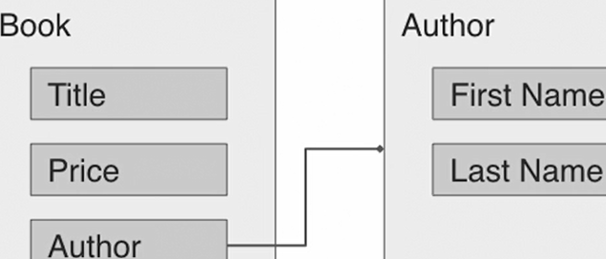**// 205 Composition**

*In below example for* ***composition****, we are using Chapter and Author to achieve complete functionality for book:*

class Author:

def __init__(self, fname, lname):

self.fname = fname

self.lname = lname

def __str__(self): return f"{self.fname} {self.lname}"

class Chapter:

def __init__(self, name, pagecount):

self.name = name

self.pagecount = pagecount

class Book:

def __init__(self, title, price, author=None):

self.title = title

self.price = price

# Use references to other objects, like author and chapters

self.author = author

self.chapters = []

def addchapter(self, chaptr): self.chapters.append(chaptr)

auth = Author("Leo", "Tolstoy")

b1 = Book("War and Peace", 39.95, auth)

b1.addchapter(Chapter("Chapter 1", 104))

*# * How Book using both Author and Chapter class instance ?*

# This is composition

**// 301 Magic Methods**

* User to customize obj behaviour and integrate with lang
* Define how objects are represented as strings
* Control access to attribute values, both for get and set
* Build in comparison and equality testing
* Allow objects to be called like functions

**// 302 String representation**

__str__ , __repr__

# The __str__ function is used to return a user-friendly string

def __str__(self): return f"{self.titl} by {self.auth}"

# The __str__ function return a developer-friendly string

def __repr__(self): return f"title={self.titl},author={self.auth}"

# use str() and repr()

print(str(b1)); print(repr(b2))

**// 303 Equality Comparison**

# the __eq__ method checks for equality between two objects

def **__eq__(**self, value): # b1 == b3

return (self.title == value.title and

self.author == value.author and

self.price == value.price)

# the __ge__ establishes >= relationship with another obj

def **__ge__(**self, value): # b1 >= b3

return self.price >= value.price

# the __lt__ establishes <= relationship with another obj

def **__lt__(**self, value): # b1 <= b3

return self.price < value.price

print(b1 == b3); print(b1 == 42) # Check for equality

# Check for greater and lesser value

print(b2 >= b1); print(b2 < b1); print(b3 >= b2)

books = [b1, b3, b2, b4] # Now we can sort them

books.sort(); print([book.title for book in books])

**// 304 Attribute access**

# Called when an attribute is retrieved. you can't directly

# access the attr name otherwise a recursive loop is created

def **__getattribute__(**self, name):

if (name == "price"):

p = super().__getattribute__("price")

d = super().__getattribute__("_discount")

return p - (p * d)

return super().__getattribute__(name)

# __setattr__ called when an attribute value is set. Don't set

# attr directly here otherwise a recursive loop causes a crash

def **__setattr__(**self, name, value):

if (name == "price"):

if type(value) is not float:

raise ValueError("The 'price' attribute must be a float")

return super().__setattr__(name, value)

# __getattr__ called when __getattribute__ lookup fails - you

# can pretty much generate attributes on fly with this method

def **__getattr__(**self, name): return name + " is not here!"

b1 = Book("War and Peace", "Leo Tolstoy", 39.95)

# Try setting and accessing the price

b1.price = 38.95; print(b1)

b1.price = float(40) # using an int will raise an exception

# If an attribute doesn't exist, __getattr__ will be called

print(b1.randomprop)

**// 305 Callable Object – call objects as function**

# the __call__ method used to call the object like a function

def __call__(self, title, author, price):

self.title = title

self.author = author

self.price = price

…

b1 = Book("War and Peace", "Leo Tolstoy", 39.95)

# call the object as if it were a function

print(b1)

b1("Anna Karenina", "Leo Tolstoy", 49.95)

print(b1)

**// 401 Define Data Class**

**// starting from 3.7 @dataclass, read more on docs**

REPLACEING BELOW CODE:

class Book:

def __init__(self, title, author, pages, price):

self.title = title; self.pages = pages; self.price = price

WITH:

from dataclasses import dataclass

**@dataclass**

class Book:

title: str = “default title”

pages: int = 0

price: float = 0.0

…. # Other things as before in normal classes

b1 = Book("War and Peace", 1225, 39.95)

b3 = Book("War and Peace", 1225, 39.95)

print(b1 == b3) # True

**// 402 Using Post initialization for @dataclass**

# __post_init__ func lets us customize additional properties

# after the object has been initialized via built-in __init__

…. # prev code from 401

def __post_init__(self):

self.description = f"{self.title} {self.pages} pages"

b1 = Book("War and Peace", "Leo Tolstoy", 1225, 39.95)

print(b1.description) # use the description attribute

**// 403 Using default values for @dataclass**

Note: if attribute without default value,

mixed with attributes with values

Then, it should come first

before the attributes with default value. Example:

@dataclass

class Book:

price: float # this is correct way

pages: int = 0

title: str = “default title”

# if this pattern is not followed then an error get raised as:

**TypeError:non-default argument ‘…’ follow default argument**

------ ------- ------ -------

Now, to pass random/generated default value for any field

from dataclasses import dataclass, field

import random

def price_func(): return float(random.randrange(20, 40))

@dataclass

class Book:

# you can define default values when attributes are declared

title: str = "No Title"; author: str = "No Author"

pages: int = 0

price: float = field(default_factory=price_func)

# it could be field(default_factory=10.0)

**// 404 Immutable dataclasses**

from dataclasses import dataclass

# "The "frozen" parameter makes the class immutable

@dataclass(frozen=True)

class ImmutableClass:

value1: str = "Value 1"; value2: int = 0

def somefunc(self, newval): self.value2 = newval

obj = ImmutableClass()

print(obj.value1)

# attempting to change the value of an immutable class

# throws an exception

**# dataclasses.FrozenInstanceError: cannot assign to field ..**

obj.value1 = "Another value"

print(obj.value1)

# Frozen classes can't modify themselves either

obj.somefunc(20) # raise FrozenInstanceError again

**// 501 Next Step**

**Lyn: 2019 Python Essential Libraries**

**// 101 3rd party libraries**

pypi.org // portal for 3rd party libaries

Install pip // similar to npm repo portal, backed by github

**// 102 pip overview**

// pre-installed from 3.4

pip list --outdated # find outdated packages on your system

pip install --upgrade <package-name>

pip uninstall lxml

pip install packagename=version-number

pip install Django=4.2.11 # installing specific version of packg

pip show packagename # packg info command

# shows package dependencies

**// 201 Pendulum – datetime library** // skip

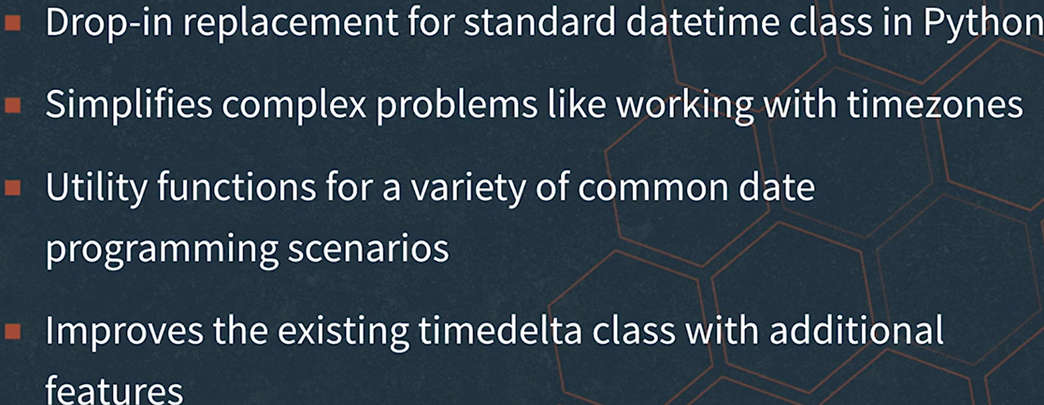# something like moment.js

**// 301 Intro to Request library // 302 Basic Requests**

# Simple http library for py, axios for js

import requests

import json

# create a basic request for data

resp = requests.get("http://httpbin.org/xml")

print(resp.status_code); print(resp.text)

# create a request using parameters

args = {"key1": 1, "key2": "two", "key3": False}

resp = requests.get("http://httpbin.org/get", params=args)

print(resp.text); print(resp.url);

# create a request using POST

resp = requests.post("http://httpbin.org/post", data={"key": "value"})

print(resp.text)

# create a request using custom headers

heads = {"my-custom-header": "This is a custom header"}

resp = requests.get("http://httpbin.org/get", headers=heads)

print(resp.text)

**// 203 Working with response**

import requests # work with status codes

# resp = requests.get('https://httpbin.org/status/404')

resp = requests.get('https://httpbin.org/status/200')

print(resp.status_code)

resp.raise_for_status() # raise exception for http error codes

# examine response encoding

resp = requests.get('https://httpbin.org/html')

print(resp.encoding)

# the text property accesses decoded text content

print(resp.text)

# the content property provides access to raw bytes

print(resp.content)

# To read JSON content, use the json() function

resp = requests.get('https://httpbin.org/json')

print(resp.json())

print(resp.headers)

print(resp.headers['content-type'])

**// 204 Using Authentication**

import requests from requests.auth

import HTTPDigestAuth

# define user and password values

user = "theuser"; passwd = "thepass";

**d = “https://httpbin.org/”**

# use the basic authentication method

url = f"{d}basic-auth/theusr/thepas"

resp = requests.get(url, auth=(user, passwd))

print(resp.status_code); print(resp.text)

# use the digest authentication method

url = f"{d}digest-auth/auth/theuser/thepass"

resp = requests.get(url, auth=HTTPDigestAuth(user, passwd))

print(resp.status_code)’ print(resp.text)

**// 305 Advanced features**

import requests

# use a timeout value for a request

resp = requests.get(f"{d}delay/0.5", timeout=1.0)

print(resp.status_code)

# introspect the redirection history

resp = requests.get("http://github.com")

print(resp.url); print(resp.history)

orig = resp.history.pop()

print(orig.status_code); print(orig.url); print(orig.reason)

# Use a session object to group requests and settings

# create the session

sess = requests.Session()

# use the session to persist a cookie across requests

sess.get(f'{d}cookies/set/sample/123456789')

resp = sess.get('https://httpbin.org/cookies')

print(resp.text)

# Customize the user-agent to simulate different browsers

# Set the user-agent to be Firefox

sess.headers.update({

"User-Agent": "Mozilla/5.0 (X11; Ubuntu; Linux x86_64; rv:68.0) Gecko/20100101 Firefox/68.0"

})

resp = sess.get("http://google.com")

print(len(resp.content))

# Set the user-agent to be an iPhone

sess.headers.update({

"User-Agent": "Mozilla/5.0 (iPhone; CPU iPhone OS 13_1 like Mac OS X) AppleWebKit/605.1.15 (KHTML, like Gecko) relesys_web_client/1.3.10.0 (RelesysApp/1.3.43 net.relesysapp.nettoenterprise)"

})

resp = sess.get("http://google.com")

print(len(resp.content))

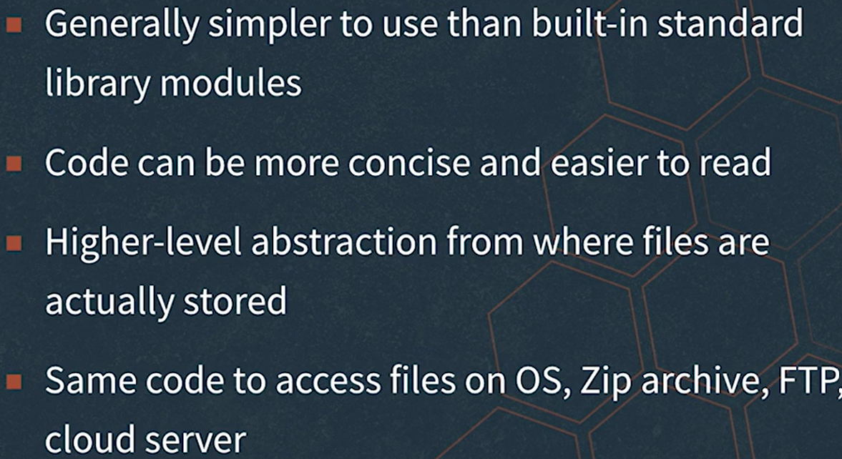**// 401 Overview PyFilesystem // skipped completely**

* python install fs

**// 501 Overview Pillow // skipped completely**

Python image library forked from PIL

**Lyn: Learning the Python 3 Standard Library**

**// 004 Standard library python**

Can be used on any machine, includes built-in functions and built-in imported modules

**// 101 Logical Operator**

If **not** True: print(‘not true’)

**// 102 Comparison Operator // 103 Calc Length**

**// 104 range and list**

🡪list takes input as tuple

🡪range(start, stop, end)

**// 105 min max** min(1, 2, 3) # 1

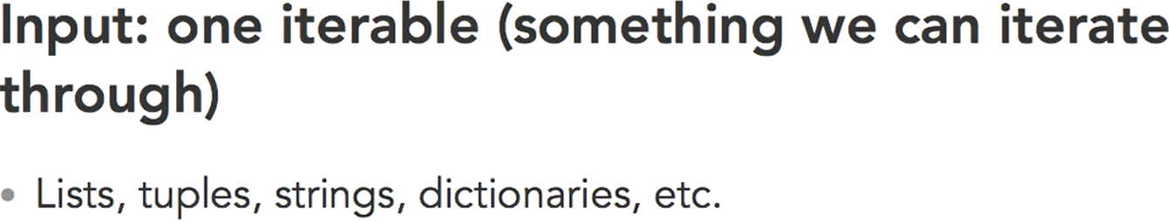**// 106 round absolute exponents**

a = 2.3; b = round(a) # 2

a = -2.3; b = abs(a) # 2.3

pow(2, 3) # 8

**// 107 Sorted func**

# Alphabetically

children = ["Sue", "Jerry", "Linda"]

print(sorted(children))

print(sorted(["Sue", "jerry", "linda"]))

# Key Parameters

print(sorted("My favorite child Linda".split(), **key=str.upper**))

# sort case-insensitive manner putting key=str.upper

leaderBoard = {231: "CKL", 123:"ABC", 432:"JKC"}

print(sorted(leaderBoard, **reverse=True**))

print(leaderBoard.get(432))

students = [ ('alice', 'B', 12), ('eliza', 'A', 16), ('tae', 'C', 15)]

print(sorted(students, **key=lambda student:student[0]))**

print(sorted(students, **key=lambda student:student[1**]))

**// 108 Type Functions** type, isinstance

**// 201 Trignometry ceiling floor constants # math lib**

# read docs for more on math

**// 202 factorial Sqrt gcd radians degress via math**

**// 203 random**

random.random, randrange, sample, choice, shuffle

**// 204 Statistics**

import statistics

.mean, .mode, .median, .variance, .stdev

**// 205 Iterators with itertools**

import **itertools**

# Infinite Counting, second parameter is step size

for x in **itertools.count(50, 5)**: # count start from 50

print(x) # 50 55 60 …..

if x == 80: break;

x = 0;

# Infinite Cycling

for c in **itertools.cycle([1, 2, 3, 4])**:

print(c)

x = x + 1

if x > 50: break; # break after 50 cycles

# Infinite Repeating

for r in **itertools.repeat(True):**

print(r)

x = x + 1

if x > 100: break; # break after 100 cycle

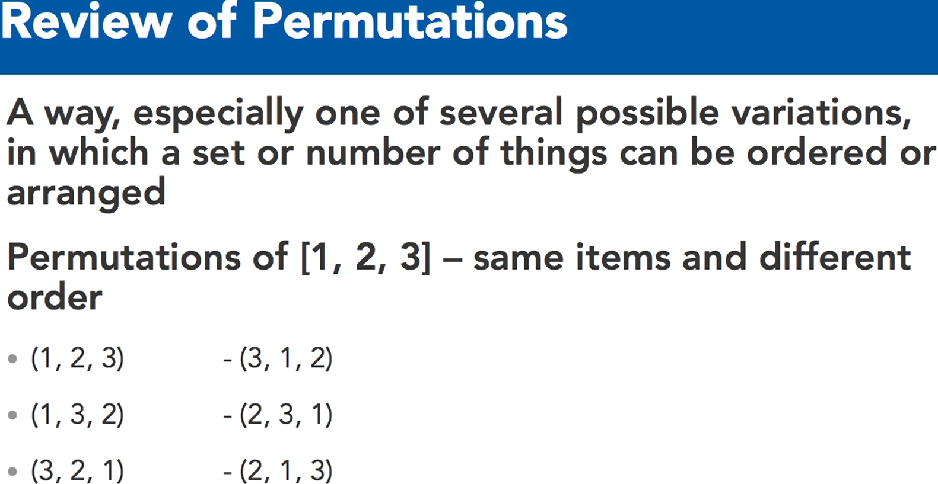**// 206 Iterators with Permutation combinations**

# Permutations: Order matters - some copies with same inputs but in different order

election = {1: "Barb", 2:"Karen", 3:"Erin"}

for p in itertools.**permutations(election)**:

print(p) # (1,2,3) (1,3,2) …..

for p1 in **itertools.permutations(election.values()):** print(p1)

# Combinations: Order does not matter - no copies with same inputs

colorsForPainting = ["Red", "Blue", "Purple", "Orange", "Yellow", "Pink"]

for c in **itertools.combinations(colorsForPainting, 3**): print(c)

**// 301 Command line arguments**

# py script.py arg1 arg2 arg3 …

import sys

# Print Arguments

print("Number of arguments: ", len(sys.argv), ' arguments.')

print("Arguments ", sys.argv)

# Remove Arguments

sys.argv.remove(sys.argv[0])

**// 302 Input Output // 303 File file writing // 304 File seeking**

**// 305 Iterative files // 306 Temp Files** // skipped

**// 307 Manipulate zip files** # Zipfile Module

import zipfile

zip = **zipfile.ZipFile**('Archive.zip', 'r') # Open and List

print(zip.namelist()) # print list of file names in zip

# Metadata in the zip folder

for meta in **zip.infolist**(): print(meta) # file properties

info = **zip.getinfo**("purchased.txt"); print(info)

# Access to files in zip folder

print(zip.read("wishlist.txt"))

**with zip.open**('wishlist.txt') as f: print(f.read())

# Extracting files

zip.extract("purchased.txt")

zip.extractall()

zip.close() # Closing the zip

**// 401 Current time // 402 Format date time** # skipped

**// 403 Calculate future times** # timedelta skipped

**// 404 Timer** # time module

time.sleep(1)

**// 405 HTML parser** # skipped

**// 406 Text Wrap** # textwrap module

**import textwrap**

websiteText = """ Learning can happen anywhere with our apps on your computer,

mobile device, and TV, featuring enhanced navigation and faster streaming

for anytime learning. Limitless learning, limitless possibilities."""

print("No Dedent:"); print(**textwrap.fill**(websiteText))

print("Dedent") # remove common leading whitespaces

dedent_text = **textwrap.dedent**(websiteText).**strip()**

print(dedent_text)

# strip remove space at begin and end of string, also /n

print("Fill"); print()

print(textwrap.fill(dedent_text, **width=50**))

print(**textwrap.fill(**dedent_text, **width=100))**

print("Controlling Indent")

print(**textwrap.fill**(dedent_text, **initial_indent=" ", subsequent_indent=" "))**

print("Shortening Text")

short = **textwrap.shorten**("LinkedIn.com is great**!", width=15, placeholder="..."**)

print(short)

**// 407 Http package urllib and json**

import urllib.request

import json

import textwrap

with urllib.request.urlopen("https://www.googleapis.com/books/v1/volumes?q=isbn:1101904224") as f:

text = f.read()

decodedtext = text.decode('utf-8')

print(textwrap.fill(decodedtext, width=50))

print()

obj = json.loads(decodedtext)

print(obj['kind'])

print(obj['items'][0]['searchInfo']['textSnippet'])

**Lyn: Python Standard Library Essential Training**

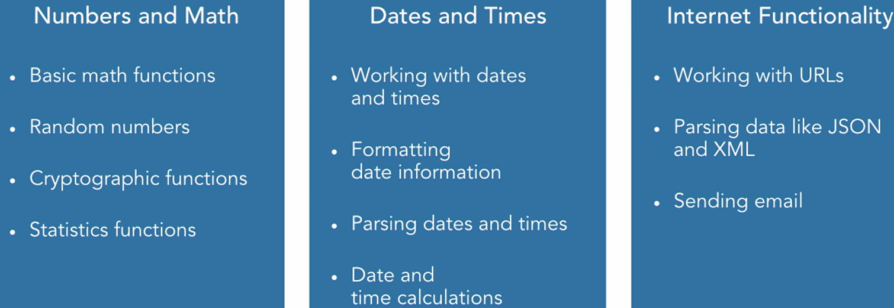**// 003 Overview**

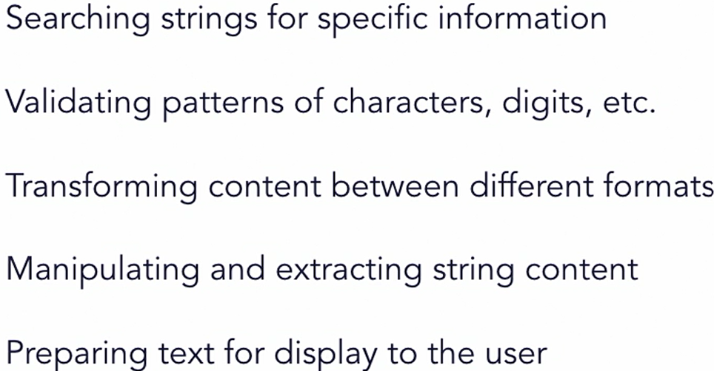**// 101 Text Processing**

**// 102 Basic string operations**

import string

# predefined string constants used in common scenarios

print(string.ascii_letters); print(string.digits)

print(string.hexdigits); print(string.punctuation)

# Use the constants to filter information out

t_str1 = "The quick brown fox jumps over the lazy dog on the 1st of December"

t_str2 = "Supercalifragilistic"; t_str3 = "90210"

print("".join([c for c in t_str1 if c in string.ascii_letters]))

# String testing methods

print(t_str1**.isalnum**()); # False

print(t_str2**.isalpha**()) # True

print(**any**([c**.isalpha**() for c in t_str1])); # True

print(t_str3**.isnumeric**()) # True

**// 103 Searching String for specific data**

sampleStr = "The the quick brown fox jumps over the lazy dog"

# startsWith and endsWith functions

print(sampleStr.**startswith**("the")) #False

print(sampleStr.**endswith**("dog")) #True

# the find and rfind functions

print(sampleStr.**find**("the")) # 4

print(sampleStr.**rfind**("the")) # 35

print("the" in sampleStr) # True

# using replace

newStr = sampleStr.**replace**("lazy", "tired");

# counting instances of substrings

print(sampleStr.**count**("over")) # 1

**// 104 String manipulate**

test_string1 = "The quick brown fox jumps over the lazy dog on the 1st of December"

# Use the split and join functions

result = test_string1.split(" ")

print(result)

letters = ["a", "b", "c", "d", "e"]; print(", ".join(letters))

# use justification functions to align strings

# ljust, center, rjust

names = ["Amy", "John", "George", "Michael", "Penelope"]

biggest = max(len(name) for name in names)

for name in names:

print(name.**ljust**(biggest+2, "-") + ":")

print(name.**center**(biggest+2, "-") + ":")

print(name.**rjust**(biggest+2, "-") + ":")

# Use a translation table to replace characters

sample_str = "The quick brown fox jumped over the lazy dog"

trans_table = str.**maketrans**("abegilostz", "4636110572")

print(sample_str)

print(sample_str.**translate**(trans_table))

**// 105 String Formating // 106**

# String formatting methods and best practices

**from string import Template**

import datetime

# Using Template strings

the_str = "The quick brown $animal $action over the lazy dog"

the_template = **Template**(the_str)

output_str = **the_template.substitute(animal="fox", action="jumped");** print(output_str)

args = { "animal": "cow", "action": "walked" }

output_str = **the_template.substitute(args);** print(output_str)

foo = "foo"; bar = 123

print("Output: **{var2:x}, {var2:X}, {var1}".format(var1=foo, var2=bar)**)

# Using interpolation with f-strings in Python 3.6

product = "Widget"; price = 19.99; tax = 0.07

nyd = **datetime.datetime(2019, 1, 1)**

print(f"{product} has a price of {price}, with tax **{tax:.2%}** the total is {round(price + (price * tax), 2)}")

# 19.99, with tax 7.00% the total is 21.39

print(f"But only on: **{nyd:%B %d, %Y}")**

# But only on: January 01, 2019

**// 201 sorted func**

testScores = [82, 67, 94, 73, 79, 86, 58, 91, 89, 71, 88, 77, 84]

sortedScores = sorted(testScores) **# descending order default**

# explicitly declare a sort order - ascending and descending

sortedScores = sorted(testScores**, reverse=True**) **# ascend**

**// 202 sorting with key params**

# the key parameter can be used to sort complex objects

class Product():

def __init__(self, name, price, weight, discount):

self.name = name; self.price = price

self.weight = weight; self.discount = discount

def __repr__(self):

return repr((self.name, self.price, self.weight))

def discountPrice(self):

return self.price - (self.price * self.discount)

prodList = [ Product("Widget", 50, 10, 0.05),

Product("Doohickey", 40, 8, 0.15),

Product("Thingamabob", 35, 12, 0.0) ]

# use the key parameter to select a field to sort on

def prodsort(product):

return product.price

print(sorted(**prodList, key=prodsort**)) **# ascend order default**

# use the key parameter to select a field to sort on

print(sorted(**prodList, key=lambda p: p.price**))

# the key parameter can also call a method on the object

print(sorted(**prodList, key=lambda p: p.discountPrice()))**

**// 203 Sorting Stability**

# sort by two different keys, taking advantage of stability

result = sorted(prodList, key=lambda p: p.weight)

print(sorted(result, key=lambda p: p.price, reverse=True))

**# when key used then reverse will make order descending**

**// 204 Sort Operators**

# the operator module functions provide easy ways to select fields attrgetter() retrieves a given attribute or property from an object itemgetter() retrieves an item at a given index in a collection methodcaller() calls the given method on the object

print("Using the attrgetter method:")

print(**sorted(prodList, key=attrgetter("weight"), reverse=True))**

print("Using methodcaller to invoke a method:")

print(sorted(**prodList, key=methodcaller("discountPrice")))**

# Use itemgetter to retrieve an index

invent = [("WidA", 5), ("WidB", 2), ("WidC", 4), ("WidD", 7)]

print(sorted(**invent, key=itemgetter(1)**))

**// 205 Sort Efficient using array**

**# The array type can hold homogeneous data types and operate on them more efficiently while using less memory**

from array import array

from sys import getsizeof

# Create an array of integer numbers

arr1 = array('i', [2, 4, 6, 8, 10, 12, 14, 16, 18, 20])

print(arr1.typecode) # i

print(arr1.itemsize) # 4

# Add additional items to the array

arr1.**insert**(3, 0) # push at [3] index value 0

arr1.**append**(22) # push to arr1

arr1.**extend**([24, 26, 28]) # push to arr1

print(arr1)

# iterate over the array content like any other list

for i, elem in **enumerate**(arr1):

arr1[i] = elem*2

print(arr1)

# Try to add a non-integer number to the array

# arr1.**insert**(0, 1.25)

# TypeError: ‘float’ object cannot be interpreted as an integer

# Create an array to hold bytes instead of ints

arr2 = array('B', [18, 102, 182, 56, 89, 5, 254, 32, 64, 50])

print(arr2.**typecode**) # B

print(arr2.**itemsize**) # 1

# try to add an item that's out of range

# arr2.append(300)

# Convert an array to a list

list1 = **arr2.tolist()**

print(list1); print(**getsizeof(list1))** # 136

**// 206 Sort Bisect #**functions to maintain a list in sorted order

import bisect

values = [5, 7, 13, 20, 25, 31]

# exercise the left and right bisection routines

print(bisect.**bisect**(values, 20)) # 4 # default right

print(bisect.**bisect_right**(values, 20)) # 4

print(bisect.**bisect_left**(values, 20)) # 3

# use insort to insert new items

bisect.**insort_right**(values, 20) # will insert to the right

print(values) # 5, 7, 13, 20, 20, 25, 31]

bisect.**insort_left(**values, 13) # will insert to the left

print(values) # 5, 7, 13, 13, 20, 20, 25, 31]

// My understanding, that bisect function to identify cutoff points where the new element should be entered to keep things sorted in final output array. Example:

# bisect can be used as an array lookup using breakpoints

breakpoints = [60, 70, 80, 90]

gradeLetters = '**FDCBA**'

scores = [81, 68, 53, 91, 90, 82, 76, 71, 84]

def calcGrade(score):

# bisect function to identify cutoff points for the letter grades

i = bisect.**bisect**(breakpoints, score)

return gradeLetters[i]

results = [calcGrade(score) for score in scores]

print(results) # ['B', 'D', 'F', 'A', 'A', 'B', 'C', 'C', 'B']

**// 301 Basic file operations** # skipped

**// 302 Create temporary file and directory**

**// 303 Reading CSV files // 304 Writing CSV**

**import csv** # Inbuilt-module with py to read/write csv

# Reading and writing Comma Separate Values files

# list the dialects that are available to use

print(csv.list_dialects())

# Open a CSV file and read each row of data

def readerSample():

with open("StockQuotes.csv") as dataFile:

reader = **csv.reader(dataFile)**

for row in reader:

print(row)

# Use the CSV module Sniffer to see what dialect of CSV this is

def useSniffer():

**with open("StockQuotes.csv") as csvfile:**

dialect = **csv.Sniffer().sniff(csvfile.read(1024))**

csvfile.seek(0)

hasHeader = **csv.Sniffer().has_header(csvfile.read(1024))**

csvfile.seek(0)

print("Headers found: " + str(hasHeader))

print(dialect.delimiter)

print(dialect.escapechar)

print(dialect.quotechar)

# Write data to a CSV file

def writerSample():

**with open("SampleData.csv", mode="w") as csvfile:**

# create a csv writer

csvWriter = **csv.writer(csvfile)**

# write the header

**csvWriter.writerow(["**Name", "Department", "Location"])

# write a few rows

csvWriter.writerow(["John Doe", "Accounting", "San Francisco CA"])

csvWriter.writerow(["Jane Dae", "Engineering", "Seattle WA"])

**// 305 Working with Zip files**

**// 306 Configuration files**

# read the contents of configuration files

import configparser

# Create the configuration parser

parser = configparser.ConfigParser()

parser.read("config.cfg") # Read the configuration file

# print the sections

print(parser.sections()) # ['Section 1', 'Section 2']

print(parser.has_section("Section 1")) # True

# Access one of the default values

using_time_travel = bool(parser['DEFAULT']['UseTimeTravel'])

print(using_time_travel) # True

print(type(using_time_travel)) # <class ‘bool’>

# Demonstrate the getXXX convenience functions

opd = parser['DEFAULT'].getboolean('ObeyPrimeDirective')

print(opd) # False

speed = parser['DEFAULT'].getfloat('Ship Speed')

print(speed) # 56324.586

# Access a non-existent value

try:

title = parser['Section 3']['Title']; print(title)

except **KeyError as err**: print("Whoa! There is no ", err)

**// 401 random numbers**

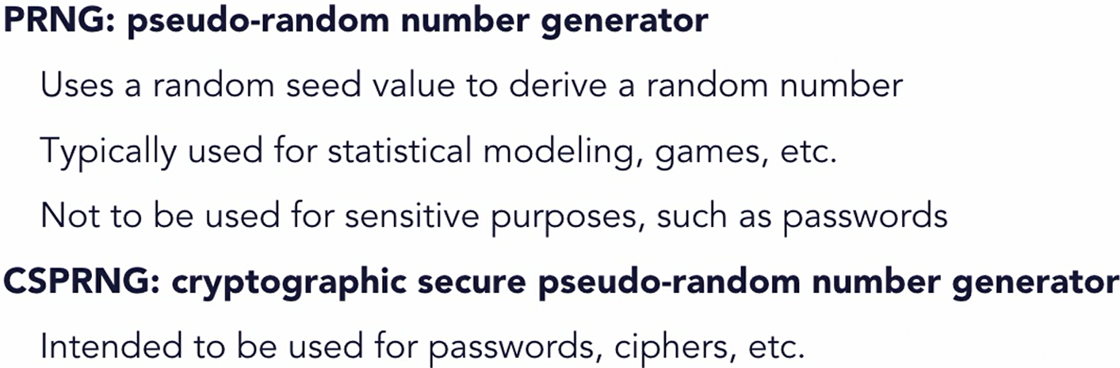There are types of random number

# demonstrate using random module to create numbers

import random

# implement a coin toss function

for i in range(10):

if (random.random() <= 0.5): print("Heads")

else: print("Tails")

# get a random number within a range

print(random.**uniform**(1, 100)) # 50.987…

# generate random integers within a given range

print(random.**randint**(1, 100)) # 17

# generate random integers with a step function

# this example chooses from 0 to 100 stepped by 5

print(random.**randrange**(0, 101, 5)) # 95

# Use the seed function to position the generator

random.**seed**(1)

print(random.random()) # 0.134….

print(random.random()) # 0.847…

print("----------------")

random.**seed**(1) # will result the same as above

print(random.random()) # 0.134….

print(random.random()) # 0.847…

**// 402 random sequence operations**

import string

# Use the choice function to randomly select from a sequence

moves = ["rock", "paper", "scissors"]

print(random.choice(moves))

# Use the choices function to create a list of random elements

roulette_wheel = ["black", "red", "green"]

weights = [18, 18, 2]

print(random.choices(**roulette_wheel, weights, k=10**))

# k means run 10 times and get 10 choices

# without weight it will be random

# with weight we are giving priority to items for random selection

------ ------- ------ -------

# chosen items are not reselected in output

chosen = random.sample(string.ascii_uppercase, 6)

print(chosen)

# The shuffle function shuffles a sequence in place

players = ["Bill", "Jane", "Joe", "Sally", "Mike", "Lindsay"]

random.shuffle(players); print(players)

# shuffle an immutable sequence, use sample function first

result = random.sample(string.ascii_uppercase, k=len(string.ascii_uppercase))

random.shuffle(result)

print(''.join(result))

**// 403 random cryptographical secure** // from 3.6

# Using cryptographic methods to generate random data

# that may be sensitive. secrets module in Python 3.6

import os

import secrets

# the urandom() in OS module produce random numbers that

# are cryptographically safe to use for sensitive purposes

result = os.urandom(8); print([hex(b) for b in result])

# secrets.choice is same as random.choice but more secure

moves = ["rock", "paper", "scissors"]; print(secrets.choice(moves))

# secrets.token_bytes generates random bytes

result = secrets.token_bytes(); print(result)

# secrets.token_hex creates a random string in hexadecimal

result = secrets.token_hex(); print(result)

# secrets.token_urlsafe generate character that can be in URLs

result = secrets.token_urlsafe(); print(result)

**// 404 Temporary password**

# Create a temporary password using Python

import secrets import string

# Function to return a temporary password given a length

def generateTempPass(numChars=8):

potentialChars = string.ascii_letters + string.digits + "+=?/!@#$%*"

result = ''.join(secrets.choice(potentialChars) for i in range(numChars))

return result

# Function to return a temporary password and enforce 1 number and 1 uppercase

def generateBetterPass(numChars=8):

potentialChars = string.ascii_letters + string.digits + "+=?/!@#$%*"

while True:

result = ''.join(secrets.choice(potentialChars)

for i in range(numChars))

# if the password has at least one number and one uppercase char we can stop

# else the loop will keep on generating random secret

if (any(c.isupper() for c in result)

and any(c.isdigit() for c in result)):

break

return result

# create a temporary password

print(generateTempPass(10))

# create a stronger temporary password

print(generateBetterPass(10))

# create a temporary, hard-to-guess URL

resultUrl = "https://my.example.com?reset="

resultUrl += secrets.token_urlsafe(15)

print(resultUrl)

**// 405 Unique Identifier** # Generating unique identifiers

import uuid

# use the uuid4 function to create a random sequence using

# the underlying os.urandom() function

# 128-bit string value

resl = uuid.uuid4()

print("UUID4: "); print(resl); print(resl.hex); print(resl.urn)

# create a UUID using uuid5, which takes a namespace and

# name value. Note that this version is not crypto-safe

res = uuid.uuid5(uuid.NAMESPACE_DNS, "example.com")

print("UUID5: "); print(res); print(res.hex); print(res.urn)

**// 406 Statistics function** # for median, average, mean

# for basic operation built-in library works // skipped

# for advance operation use 3rd party like numpy, etc.

**// 501 Basic dates times**  # skip

**// 502 Date_time format // 503 calc dates_times** # skip

**// 601 Working with URLs** # urllib

import urllib.parse # Using the URL parsing functions

sample_url = "http://server.example.com:8080/example.html?val1=1&val2=Hello+World"

# parse a URL with urlparse()

result = urllib.parse.urlparse(sample_url)

print(result)

print(result.scheme, result.hostname, result.path)

print(result.geturl())

# quote() replaces special characters for use in URLs

sample_string = "Hello El Niño"

print(urllib.parse.quote(sample_string))

print(urllib.parse.quote_plus(sample_string))

# Use urlencode() to convert maps to parameter strings

query_data = {

'Name': "John Doe", "City": "Anytown USA", "Age": 37 }

result = **urllib.parse.urlencode(query_data);** print(result)

**// 602 Retrieving internet data** # skip

import urllib.request

**// 603 HTML** # skip

from html.parser import **HTMLParser**

**// 604 JSON** # working with JSON data

import urllib.request; import json

req = urllib.request.urlopen("http://httpbin.org/json")

data = req.read().decode('utf-8'); print(data)

obj = json.**loads**(data); print(obj["slideshow"]["author"])

for slide in obj["slideshow"]["slides"]: print(slide["title"])

# python objects can also be written out as JSON

objdata = { "name": "Joe Marini", "author": True, "titles": [ "Learning Python", "Advanced Python", ]}

**with open("jsonoutput.json", "w") as fp:**

json.**dump**(**objdata, fp, indent=4)**

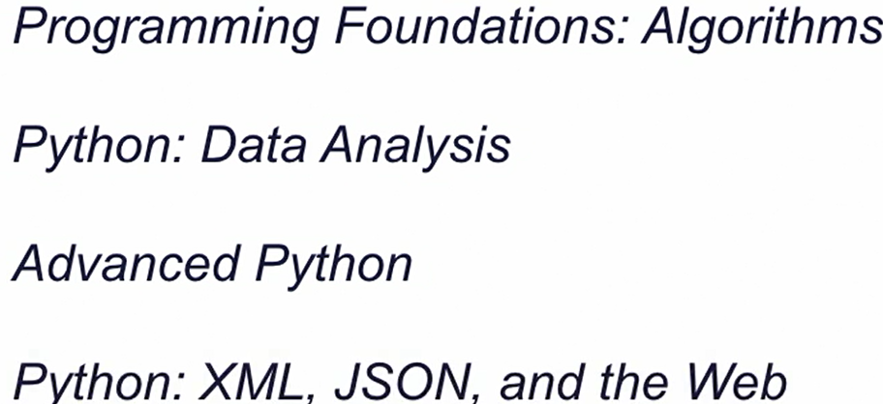**// 701 Next**